A **PROJECT REPORT**

ON

**Smart Integrated Automation System for Industrial and Domestic Purpose**

Submitted for partial fulfilment of the award of

**BACHELOR OF TECHNOLOGY**

In

ELECTRONICS & COMMUNICATION ENGINEERING

By

**Mudit Pratap Singh (1814331029)**

**Nitesh Upadhyay (1814331035)**

**Prabhat Mittal (1814331036)**

**Kritika Nath (1814331026)**

Guided by

Prof. Praveen Chaurasia (Assistant Professor)

Department of Electronics & Communications, IMS Engineering College, Ghaziabad



**DR. A. P. J. ABDUL KALAM TECHNICAL UNIVERSITY,**

**LUCKNOW**

**May 2022**

**CERTIFICATE**

It is to certify that **Mudit Pratap Singh**, **Nitesh Upadhyay**, **Prabhat Mittal,** and **Kritika Nath** have carried out the research work presented in this project entitled **“Smart Integrated Automation System for Industrial and Domestic Purpose”** for the award of **Bachelor of Technology** from DR. A. P. J. Abdul Kalam Technical University, Lucknow under my supervision. The project embodies the result of original work and studies carried out by students themselves. The content of the project does not form the basis for the award of any other degree to the candidate or to anybody else.

Date: Prof. Praveen Chaurasia (Assistant Professor)

i

**DECLARATION**

We hereby declare that this submission is our own work and that, to the best of our knowledge and belief, it contains no material previously published or written by another person nor material which to a substantial extent has been accepted for the award of any other degree or diploma of the university or another institute of the higher learning, except where due acknowledgment has been made in the text.

Signature: Signature:

Name: Mudit Pratap Singh Name: Nitesh Upadhyay

Roll No.: 1814331029 Roll No.: 1814331035

Date: Date:

Signature: Signature:

Name: Prabhat Mittal Name: Kritika Nath

Roll No.: 1814331036 Roll No.: 1814331026

Date: Date:

ii

**ACKNOWLEDGEMENT**

We have taken efforts in this project. However, it would not have been possible without the support and help of many individuals and organizations. First of all, we would like to extend our sincere thanks to our project guide **Dr. Praveen Chaurasia** for his guidance and constant supervision as well as for providing necessary information regarding the project & also for his support in completing the project.

We are highly indebted to our Project coordinator **Prof. Balwant Singh** for allowing us to work under his supervision.

We would like to express our deep sense of gratitude to **Prof. Jyoti Guglani**, Head of the Department of Electronics and Communication for his constructive advice and valuable comments which were helpful for the improvement of qualitative work.

We would like to express our gratitude towards our parents & members of IMS Engineering College for their kind co-operation and encouragement which help us in the completion of this project.

We would like to express our special gratitude and thanks to industry persons for giving us such attention and time.

Our thanks and appreciation also go to our colleagues in developing the project and people who have willingly helped us out with their abilities.

iii

**ABSTRACT**

Automation device has a wide scope for this Generation as well as in forthcoming generation. In this wide scope, Mobile communication technology is playing a major role in the world of automation but in today’s world upgrading the automation system is a major concern. It became more costly when the automation system needs up-gradation. As a solution, we have successfully implemented a smart integrated automation system for both industrial and domestic purposes and by this system, we can easily expand our existing automation system. This article is fully based on a low-cost and reliable automation system for accessing and controlling devices and appliances remotely using an Android-based Smartphone application. we worked with three major goals that are Provide an expendable automation circuit by user end, that can implement for both industrial and domestic automation and last, and this is open source re-programmable.

iv

**TABLE OF CONTENTS**

**Title Page No.**

CERTIFICATE i

DECLARATION ii

ACKNOWLEDGEMENT iii

ABSTRACT iv

TABLE OF CONTENT v

LIST OF FIGURES vii

LIST OF TABLES ix

CHAPTER 1 1

INTRODUCTION 1

LITERATURE REVIEW 2

TYPES OF AUTOMATION SYSTEM 3

Bluetooth based Home Automation System using Cell Phones: 3

Zigbee based Home Automation System using Cell Phones: 3

Gsm based Home Automation System using Cell Phones: 4

Wi-fi based Home Automation System using Cell Phones: 5

Home Automation using RF Module: 6

Home Automation using android ADK: 7

Cloud Based Home Automation System: 8

Raspberry Pi Automation with Wireless Sensors using Smart Phone: 9

Wireless Home Automation System using IOT: 10

CHAPTER 2 12

BRIEF DESCRIPTION 12

COMPONENT DESCRIPTION 14

Node-MCU 14

Relay Board 15

IR Sensor 16

Voltage Regulator 17

Buzzer BC547 18

Transistor 19

SOFTWARE REQUIREMENT 20

v

Arduino IDE 20

Fritzing Software Tool 21

Blynk App (Open s/w) 21

CHAPTER 3 22

CIRCUIT DIAGRAM & IMPLEMENTATION OF PROPOSED SYSTEM 22

FIRST PROTOTYPE AUTOMATION SYSTEM BASED ON A

SINGLE NODE-MCU 22

FINAL PROTOTYPE AUTOMATION SYSTEM BASED

ON DUAL NODE-MCU 25

CHAPTER 4 27

RESULT AND CONCLUSION 27

Result 27

Advantages 27

Limitation 27

Conclusion 28

Reference

vi

**LIST OF FIGURES**

**Figure No. Name of Figure Page No.**

Figure 1 Bluetooth based Home Automation System using Cell Phones 3

Figure 2 Zigbee based Home Automation System using Cell Phones 4

Figure 3 GSM based Home Automation System using Cell Phones 5

Figure 4 Wi-Fi based Home Automation System using Cell Phones 6

Figure 5 Home Automation using RF module 7

Figure 6 Home Automation using Android ADK 8

Figure 7 Cloud Based Home Automation System 9

Figure 8 Sending Commands to the Raspberry Pi 10

Figure 9 Receiving Data from the Raspberry Pi 10

Figure 10 Wireless Home Automation System using IoT 11

Figure 11 Pin Diagram of Node-MCU 14

Figure 12 Relay Board 15

Figure 13 IR Sensor 16

Figure 14 Pin Diagram of Voltage Regulator 17

Figure 15 Buzzer 18

Figure 16 Pin Diagram of Transistor 19

Figure 17 Diagram of single (Node-MCU ESP8266) based Automation System 22

Figure 18 Circuit diagram of external Relay circuit for our Automation System 23

Figure 19 Prototype design of using Fritzing Tool 23

Figure 20 Schematic Diagram of single Node-MCU (ESP8266) based System 24

Figure 21 First Hardware prototype 24

vii

Figure 22 Circuit diagram of dual microcontroller (ESP8266) based

Automation System 25

Figure 23 Circuit diagram of external Relay circuit for our Automation System 25

Figure 24 Final project overview 26

Figure 25 Final external Relay circuit 26

viii

**LIST OF TABLES**

**Table no. Name of Table Page no.**

TABLE 1 Pin Description of Voltage Regulator IC 7805 17

ix

**CHAPTER 1**

**SMART INTEGRATED AUTOMATION SYSTEM FOR INDUSTRIAL AND DOMESTIC PURPOSE**

**1.1 Introduction:**

In the current world, Automation system has a wide scope and it is used worldwide and becoming popular day by day but in this new technology many users are facing a problem of upgrading or expending the existing system and this is challenging. Considering the current scenario, if any user wants to expand their existing automation device, they need to install another system device for that must be another Interfacing software. This is very challenging for any user. Automation is used by these techniques, i.e., Manual and Autonomous. In the case of a manual one, automation is controlled by the user. In the case of autonomous, it can be managed by observing the use and signal of the sensor and setting the time accordingly. This project is based on the idea to solve this challenge. Now our team proposed a solution to overcome this issue we plan and design an automation circuit that contains two Node-MCU that are based on the ESP8266 microcontroller. This project is divided into two sections- the first section is containing a relay circuit and a separated Node-MCU for Relay that is designed to give mobility for expanding the relay circuit at the user end which is helpful when users want to expand their existing relay automation board. The second part contains another Node-MCU with a sensor only that will be helpful when the user needs to add new sensors to an existing circuit. Both the Node-MCU clustered which means both the microcontroller are connected over the same server and internet. The reason for using a separated microcontroller is, i.e., the user can upgrade the relay or sensor at the same time or it can be upgraded both at the same time. Our circuit system contains some sensors like an IR sensor, relay, and led display. That is used only for the demonstration and working of sensors with cluster Node-MCU system. In the Domestic automation system, we represent our home appliances are controlled via our phone applications, model is represented by the control of some bulbs via our mobile application. These bulbs are working on AC supply and the user can easily turn ON and OFF appliances via using the mobile. Another is industrial based- in the industry we know that there are many sensors working at a time and our proposed design is capable to run with multi-sensors at a time without affecting Relay and Relay’s Node-MCU.

1

**1.2 LITERATURE REVIEW**

History of Automation Systems is not so old back many years to find out some material about Automation System. When IoT was introduced, The world of Automated Machinery rapidly increased. IoT (Internet of Things), is A physical object that connects to the Internet. It can be a fitness tracker, a thermostat, a lock or appliance, or even a light bulb.

Kevin Ashton is an innovator and consumer sensor expert who coined the phrase “the Internet of Things” to describe the network connecting objects in the physical world to the Internet.

The term Internet of Things was invented in 1999, initially to promote RFID technology. But later on, it became a widely used term for connecting things via the internet. There are several similar concepts but the Internet of Things is by far the most popular term to describe this phenomenon.

Machines have been providing direct communications since the telegraph (the first landline) was developed in the 1830s and 1840s. Described as “wireless telegraphy,” the first radio voice transmission took place on June 3, 1900, providing a necessary component for developing the Internet of Things. The development of computers began in the 1950s.

The first concept of the Internet of Things was not officially named till 1999, but one of the first examples of an IoT is from the early 1980s and was a Coca-Cola machine, located at the Carnegie Mellon University.

Way back in 1898, Nikola Tesla created the first remote control to operate a toy boat. Tesla worked out a way to use radio waves to send instructions to his boat from a handheld device.

In the late 1990s and early 2000s as internet technology developed fast and smart homes suddenly became a more affordable option. Domestic technology or 'domotics' was a highly discussed topic as domestic appliances were being combined with computers. The Millennium House was a British show home opened in 1998 to demonstrate how running a home could be automated with computer-controlled heating, lights, doors, and gardens. The investigation in this study includes the classification of research and research fields in line with the research content. Further, survey results are presented and the outlook for further study is summarized.

2

**1.3 Types of Automation System:**

**1.3.1 Bluetooth-based home automation system using cell phones**[1]**:**

In Bluetooth-based home automation systems the home appliances are connected to the Arduino BT board at input-output ports using a relay. The program of the Arduino BT board is based on the high-level interactive C language of microcontrollers; the connection is made via Bluetooth. Password protection is provided so only authorized users are allowed to access the appliances. The Bluetooth connection is established between the Arduino BT board and phone for wireless communication. In this system, the python script is used and it can be installed on any of the Symbian OS environments, it is portable. One circuit is designed and implemented for receiving feedback from the phone, which indicates the status of the device.

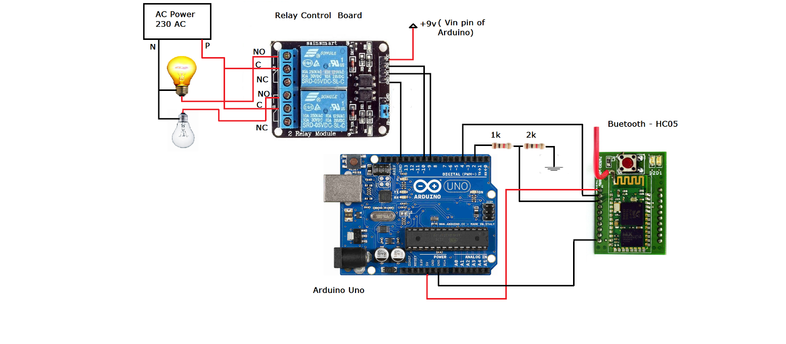

*Figure 1: Bluetooth-based home automation system using a cell phone.*

**1.3.2 Zigbee-based home automation system using cell phones**[2]**:**

To monitor and control the home appliances the system is designed and implemented using Zigbee. The device performance is recorded and stored by network coordinators. For this the Wi-Fi network is used, which uses the 4- switch port standard wireless ADSL modem router. The network SSID and security Wi-Fi parameters are preconfigured.

3

The message for security purposes is first processed by the virtual home algorithm and when it is declared safe it is re-encrypted and forwarded to the real network device of the home. Over the Zigbee network, the Zigbee controller sent messages to the end. The safety and security of all messages that are received by the virtual home algorithm. To reduce the expense of the system and the intrusiveness of respective installation of the system Zigbee communication is helpful.

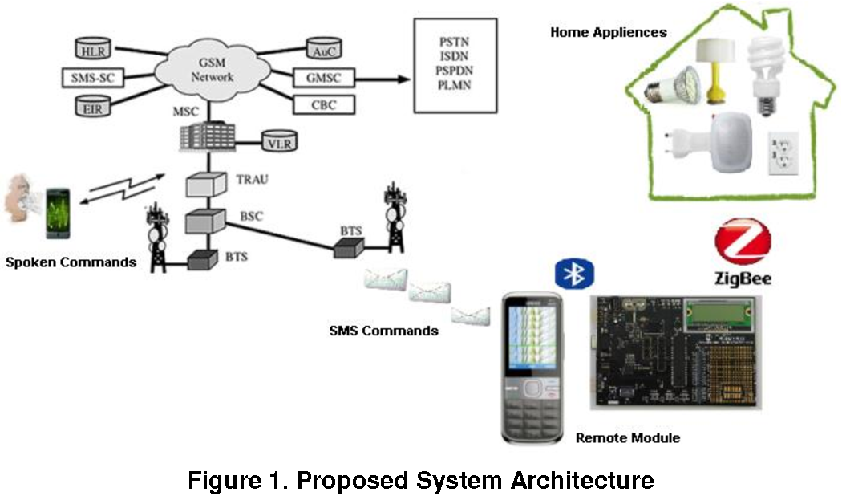

*Figure 2: Zigbee-based home automation system using cell phones*

**1.3.3 GSM-based home automation system using cell phones**[3]**:**

Because of the mobile phone and GSM technology, GSM-based home automation is a lure to research. SMS-based home automation, GPRS-based home automation, and dual-tone multi-frequency (DTMF) based home automation are these options we considered mainly for communication in GSM. The figure shows the logical diagram of the work of A. Alheraish, it shows how the home sensors and devices interact with the home network and communicates through GSM and SIM (subscriber identity module). The system uses a transducer that converts machine function into electrical signals which go into a microcontroller. The sensors of the system convert the physical qualities like sound, temperature, and humidity into some other quantity like voltage. The microcontroller analyses all signals and converts them into commands to be understood by the GSM module. Select appropriate communication methods among SMS, GPRS, and DTFC based on the command which received the GSM module.

4

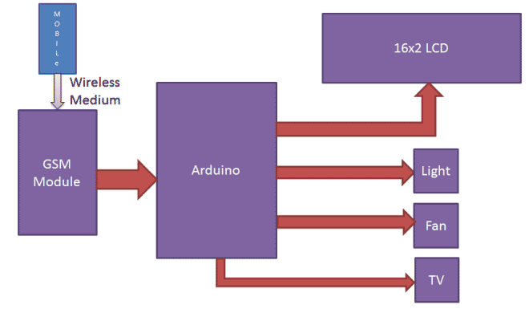

*Figure 3: GSM-based home automation system using cell phones.*

**1.3.4 Wi-Fi-based home automation system using cell phones**[4]**:**

Wi-Fi-based home automation systems mainly consist of three modules, the server, the hardware interface module, and the software package. The figure shows the system model layout. Wi-Fi technology is used by the server, and hardware Interface modules to communicate with each other. The same technology is used to log in to the server web-based application. The server is connected to the internet, so remote users can access the server web-based application through the internet using a compatible web browser. The software of the latest home automation system is split into server application software and Microcontroller (Arduino) firmware. The Arduino software, built using C language, using IDE comes with the microcontroller itself. Arduino software is culpable for gathering events from connected sensors, then applies an action to actuators and pre-programmed in the server. Another job is to report and record the history in the server DB. The server application software package for the proposed home automation system is a web-based application built using asp.net. The server application software can be accessed from an internal network or from the internet if the server has real IP on the internet using any internet navigator that supports asp.net technology. Server application software is culpable for, maintaining the whole home automation system, setup, and configuration. The server uses a database to keep a log of home automation system components, we choose to use XML files to save the system logs.

5

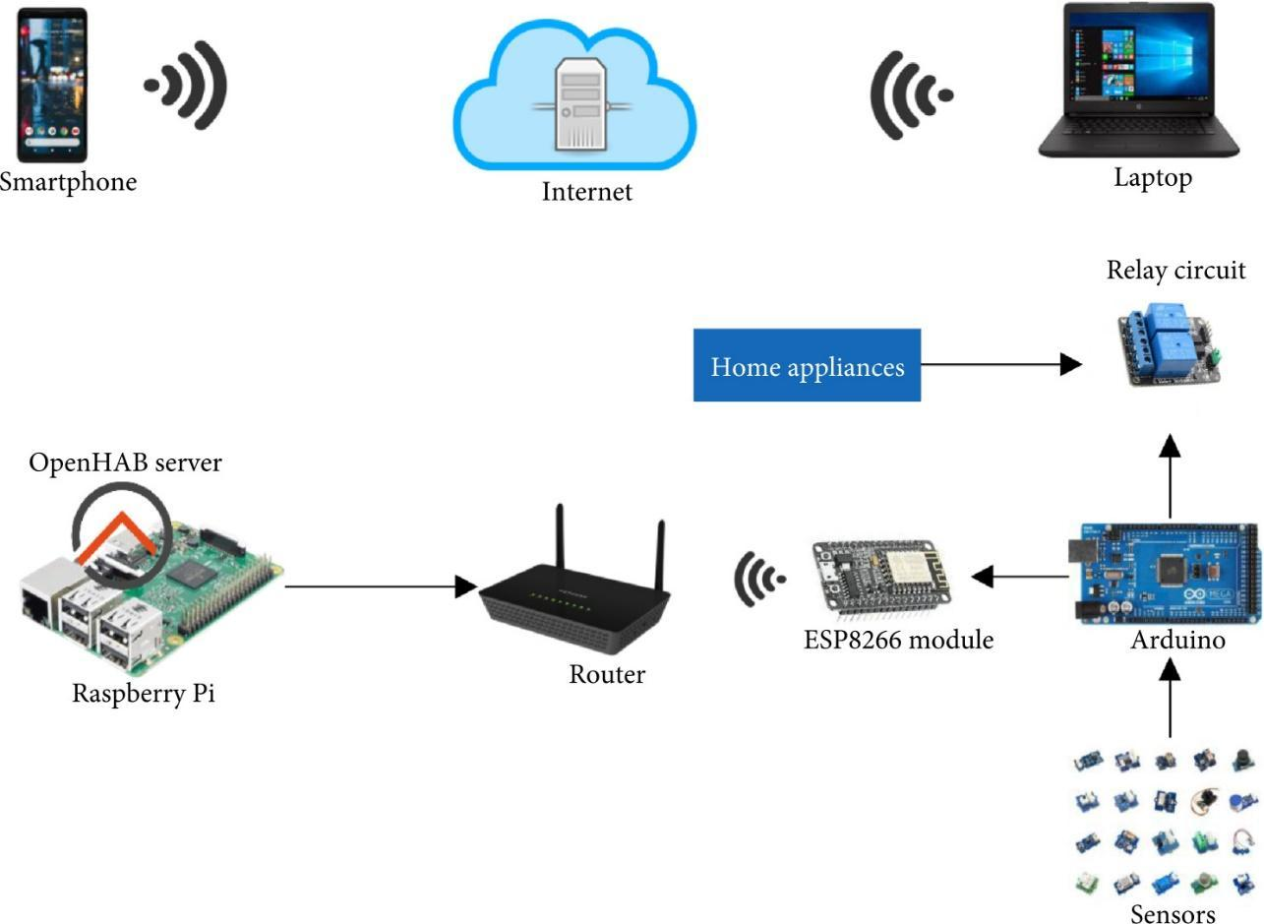

*Figure 4: Wi-Fi-based home automation system using cell phones*

**1.3.5 Home automation using RF module**[5]**:**

The important goal of the Home Automation System is to build a home automation system using an RF-controlled remote. Now technology is accelerating so homes are also getting smarter. Modern homes are deliberately relocating from current l switches to centralized control systems, containing RF-controlled switches. Today Traditional wall switches situated in various parts of the home make it laborious for the end-user to go near them to control and operate. Even further it turns into more problematic for the old persons or physically handicapped people to do so. Home Automation using remote implements an easier solution with RF technology. To accomplish this, an RF remote is combined with the microcontroller on the transmitter side that sends ON/OFF signals to the receiver where devices are connected. By operating the stated remote switch on the transmitter, the loads can be turned ON/OFF globally using wireless technology.

6

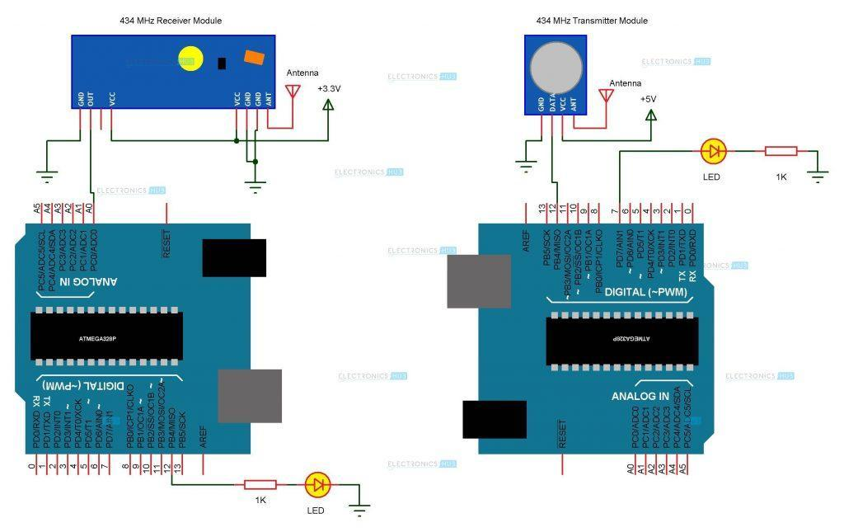

*Figure 5: Home automation using RF module*

**1.3.6 Home automation using Android ADK**[6]**:**

The devices of the home are associated with the ADK and the Connection is established between the Android device and ADK. The devices of the house are linked to the input/output ports of the board (EMBEDDED SYSTEM) and their current situation will have passed to the ADK. The microcontroller board (Arduino ADK) is based on the ATmega2560. It has a USB host connection to associate with Android-based phones, and that is based on the MAX3421e IC. The two important features of Android Open Accessory Protocol 2.0(AOAP) are as follows: It has an audio output that is from the Android device to the component and its support for the component serves as one or more Human Interface Devices (HID) to the Android device. This paper depends upon Android and Arduino platforms which both are FOSS (Free Open-Source Software). Including motion sensors for safety systems will detect an unauthorized action and it will automatically notify the user through cell phone or the security system.

7

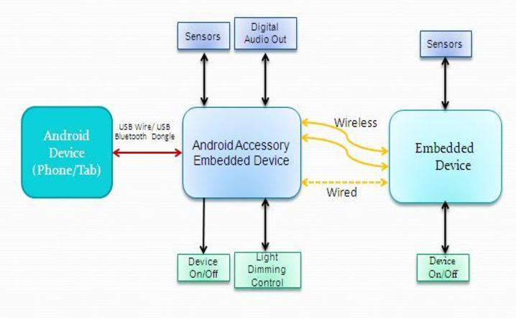

*Figure 6: Home automation using Android ADK*

**1.3.7 Cloud-Based home automation system**[7]**:**

Home Automation using a cloud-based system focuses on the design and implementation of a home gateway to collect data about data from home appliances and then send to the cloud-based data server to get the store on Hadoop Distributed File System, it is processed using MapReduce and use to implement a monitoring-tasks to Remote user Presently home Automation System is persistently developing its resilience by assimilating the current characteristics which gratify the rising interest of the people. This paper presents the design and development of home automation systems that use cloud computing as a service. The current system consists of three important units: the first part is the cloud-server, which handles and controls the data and information of clients and users and the status of devices The hardware interface module is the second part which implements the relevant connection to the actuators and sensing devices which give the physical service. The last part is Home Server, which constructs the hardware device and gives the user interface. This paper focuses on building the web services using the cloud which is needed for security and storage and availability of the data. The current system is cost-efficient, reliable, and comfortable which also gives a secured home automation system for the entire family. The system is made up of various client modules for various platforms.

8

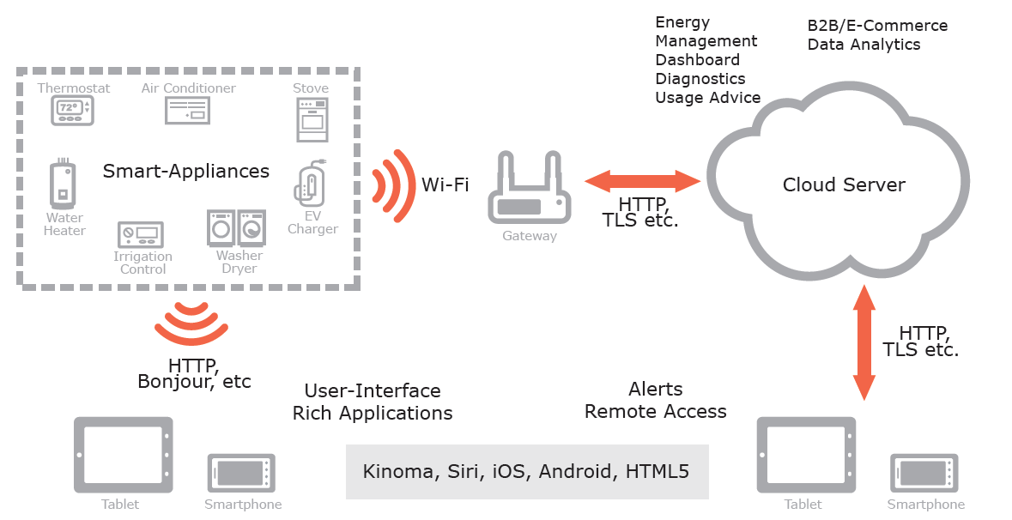

*Figure 7: Cloud-Based home automation system*

**1.3.8 Raspberry pi automation with wireless sensors using smartphones**[8]**:**

Home Automation System has been developed with Raspberry Pi by reading the algorithm and subject of the E-mail. Raspberry Pi guarantees to be an efficient platform for the implementation of powerful, and economic smart home automation. Home automation using Raspberry pi is better than any other home automation method in several ways. For example, in DTMF (dual-tone multi-frequency) using home automation, the call tariff is a big demerit, which is not the problem in their proposed method. In-Home Automation using a web server, the design of the webserver and the memory space required are dismissed by this method because it just uses the already established webserver service given by G-mail. LEDs were used to identify the switching action. This system is efficient and flexible and interactive.

**Sending Commands to the Raspberry Pi**[9]**:**

The script running on the server-side of our laptop or on a web server receives the input commands from the user and appropriately sends them to the client (Raspberry Pi). In This, we will be using those input commands to turn a light ON/OFF. When we give the command to turn ON a light by the server-side script, the data and information gets relayed to the Raspberry Pi and its GPIO pin will turn ON a relay. The system can send current updates to the server to detect whether the light is ON/OFF.

9

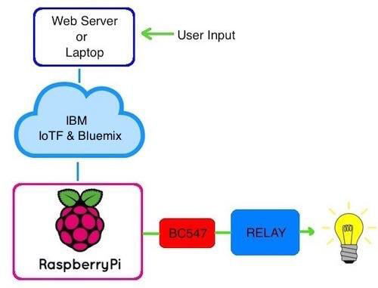

*Figure 8: Sending Commands to the Raspberry Pi*

**Receiving Data from the Raspberry Pi**[10]**:**

Using the PIR motion sensor we can send the data signal to the Raspberry Pi, we just run a script that can read the sensor by a GPIO pin and transmit the data to overall system through the IoT-F platform. This can then be looked at by the IoT console.

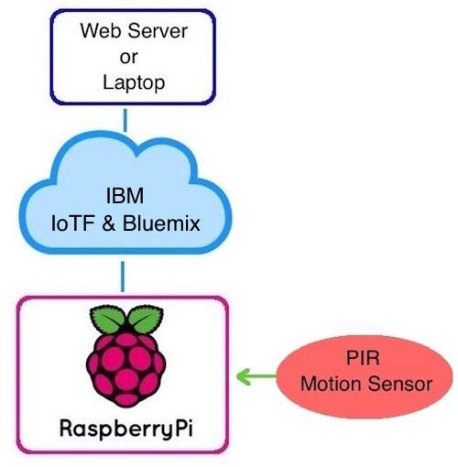

*Figure 9: Receiving Data from the Raspberry Pi*

**1.3.9 Wireless Home Automation system using IoT**[11]**:**

This system uses mobiles or computers to control basic home control and function automatically through the internet from anywhere around the world globally, an automated home is sometimes called a smart home. It is meant to save electric power and human energy. The proposed system is a distributed home automation system, consisting of servers i.e. Wi-Fi modules, and sensors. The server controls and monitors the various sensors, and can be easily configured to handle more hardware interface modules (sensors).

10

The Arduino board, with a built-in Wi-Fi module acts as a web server. Automation System can be accessed from the web browser of any local PC using server IP, or remotely from any PC or mobile handheld device connected to the internet with an appropriate web browser through server real IP (internet IP). Wi-Fi technology is selected to be the network infrastructure that connects the server and the sensors. Wi-Fi is chosen to improve system security (by using a secure Wi-Fi connection) and to increase system mobility and scalability.

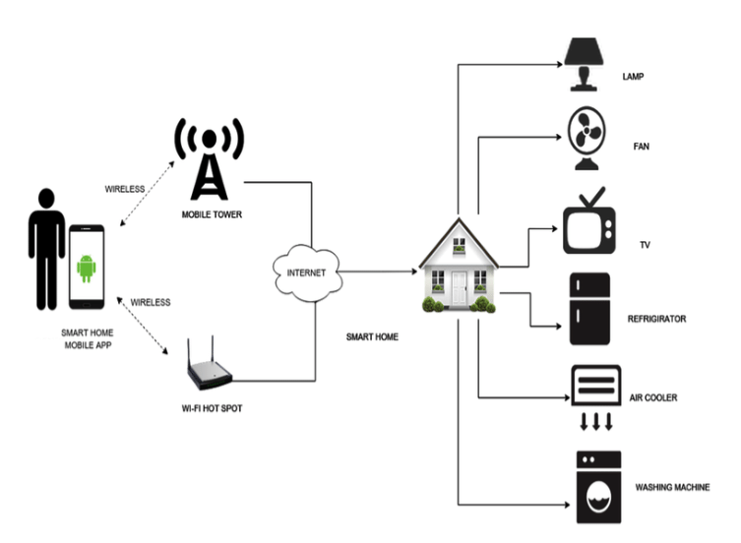

*Figure 10: Wireless Home Automation system using* IoT

11

**CHAPTER 2**

2.1 Brief Description:

Home automation, Smart Institute, Home control, and digital home are just different names for comfort, convenience, security, and power saving. These systems are of increasing importance these days. Even though such systems are very expensive in general, they can also be very economical if one designs and constructs them for very specific needs. There are many ways to control a smart home system, including wireless communication over the internet. This project will help in creating a new generation of smart automation systems in which users can control the home appliances such as refrigerators, Air conditioners, Fans, and Bulbs Industrial Appliances and Institutional things also can control. whenever they want and from wherever they are with the aid of the Internet. This can be extended by a mobile app which is an open-source platform like Android. The apps can be used to create a user interface using which one will be able to control all kinds of appliances via their Smartphone. There are 3 major modules that are required to build this system, that is Client-Server, Radio Frequency Transceiver, and Microcontroller. This system can be accessed by the internet by using a Personal Computer or Smartphone. This project consists of two parts: Hardware and Software. Hardware refers to the development of the device itself including circuit construction, printed circuit board etching, and soldering process. The software part refers to designing algorithms, coding, and compilation. It also includes the development of the user interface.

In the current world automation system has a wide scope and automation system is used world wild and becoming popular day by day but in this new technology many users are facing the problem of upgrading or expanding the existing automation system, which is challenging. If we consider the current scenario, if any user wants to expand their existing automation device they need to install another system device for that must be another Interfacing software. This is very challenging for any user. Automation is used by three techniques, i.e. manual and autonomous. In the case of a manual one, automation is controlled by the user, in the case of autonomous, it can be managed by observing the use and signal of the sensor and setting time accordingly. So, we come up with this idea to solve this challenge. Now our team proposed a solution to overcome this issue we plan and design an automation circuit that contains two Node-MCU that are based on the ESP8266 microcontroller.

12

This project is divided into two sections- the first section is containing a relay circuit and a separated Node-MCU for Relay that is designed to give mobility for expanding relay circuit at the user end which is helpful when users want to expand their existing relay automation board. The second part contains another Node-MCU with a sensor only that will be helpful when the user needs to add new sensors to an existing circuit. Both the Node-MCU clustered which means both the microcontroller are connected over the same server and internet. The reason for using a separated microcontroller is that the User can upgrade the relay or sensor at the same time or it can be upgraded both at the same time. Our circuit system contains some sensors like an IR sensor, relay, and led display. That is used only for the demonstration and working of sensors with cluster Node-MCU system. In the Domestic automation system, we represent our home appliances are controlled via our phone applications, model is represented by the control of some bulbs via our mobile application, these bulbs are working on AC supply and the user can easily turn ON and OFF appliances via using the mobile. Another is industrial based- in the industry we know that there are many sensors working at a time and our proposed design is capable to run with multi-sensors at a time without affecting Relay and Relay’s Node-MCU.

13

**2.2 Component Description:**

**2.2.1 Node-MCU:**

Node-MCU is an electronic device which is programmed by the user according to their requirements. Node-MCU is an ESP8266-based microcontroller. Node-MCU boards are able to read input – light on sensors, a finger on a button, or a Twitter message- and turn it into an output – activating a motor, turning on a led, publishing something online. Node MCU has an integrated Wi-Fi module that makes it compatible to perform tasks over the internet.

In this project, we use two Node-MCU micro-controller, both microcontrollers are connected over the same server. One of the Node-MCU is used for relay module control which is able to control AC components and the second Node-MCU is used for sensors only.

devices connected with its pin. Specifications of Arduino which is required in this project are as follows-

* Microcontroller-Atmega328p (8-bit AVR family microcontroller)
* Operating Voltage-5V
* Input Voltage -7V to 12V
* Analog pins-6
* Digital I/O pin-14
* Flash memory 32 kB (0.5 kB for the bootloader) SRAM - 2KB

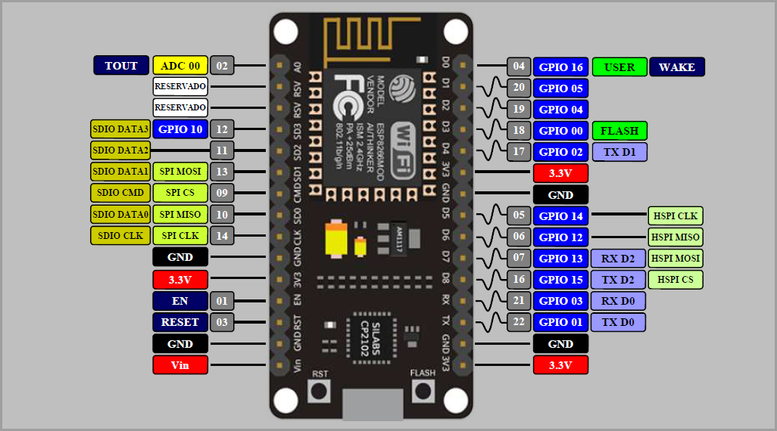

*Figure 11: Pin Diagram of Node-MCU*

14

**2.2.2 Relay Board:**

It is a kind of electro-mechanical component that functions as a switch that is commonly used in the automatic control circuit and to control a high-current using a low-current signal. The input voltage of the relay signal ranges from 0 to 5V. The relay coil is energized by DC so that contact switches can be opened or closed. A single channel 5V relay module generally includes a coil, and two contacts normally open (NO) and normally closed (NC). Working is done through a coil to magnetize the switch contacts & drag them jointly once activated. A spring drives them separately once the coil is not strengthened.

By using this system there are mainly two benefits, the first one is, that the required current for activating the relay is less as compared to the current used by relay contacts for switching. The other benefit is, that both the contacts & the coil are isolated galvanically, which means there is no electrical connection among them.

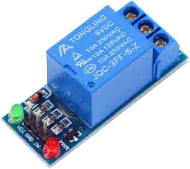

*Figure 12: Relay Board*

**Single-Channel Relay Module Specifications:**

1. Supply voltage – 3.75V to 6V

2. Quiescent current: 2mA

3. Current when the relay is active: ~70mA

4. Relay maximum contact voltage – 250VAC or 30VDC

5. Relay maximum current – 10A

**Advantages:**

1. A remote device can be controlled easily

2. It is triggered with less current but it can also trigger high power machines

3. Easily contacts can be changed

4. At a time, several contacts can be controlled using a single signal

5. Activating part can be isolated

6. It can switch AC or DC

15

**Applications:**

1. Used in over voltage/under voltage protection system

2. Mains Switching

3. Speed control of motors through start-delta converters

4. Automatic electrical appliances

5. AC voltage load switching using less voltage DC

6. Home automation projects

**2.2.3 IR Sensor:**

IR sensor is an infrared sensor that emits in order to sense some aspects of surroundings. It can measure the heat of the object as well as detects motion. It is one of the basic and popular sensor-module in electronic devices for accident detection. This sensor is equivalent to human’s visionary senses. The sensor is fixed in front of the vehicle so that the sensor monitors the obstacles. In case of any hindrance or hit the respective sensor will send a message to all the registered numbers informing them about the location and incident using the GPS system through the GSM module. This sensor should be fixed in such a way that it shall sense the obstacles. **An infrared sensor** is used to detect obstacles by transmitting **infrared** signals, this **infrared** signal is reflected from the surface of an object and the signal is received at the **infrared** receiver. The frequency range of infrared lies between the microwave and the visible light spectrum. The working of any Infrared sensor is governed by three laws: Planck’s Radiation law and Stephen.

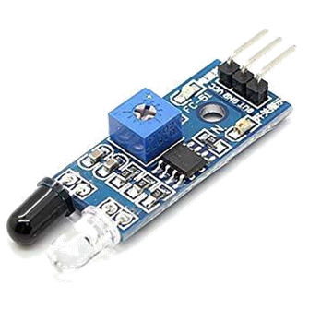

*Figure 13: IR* Sensor

16

**2.2.4 Voltage regulator:**

7805 voltage regulator IC is used in the emergency vehicle to give the 5V-supply to the Arduino Uno and IR sensor from a 12-volt battery. 7805 is a voltage regulator integrated circuit. It is a member of the 78xx series of fixed linear voltage regulator ICs. The voltage source in a circuit may have fluctuations and would not give the fixed voltage output. The voltage regulator IC maintains the output voltage at a constant value. The xx in 78xx indicates the provide 7805 provides a +5V regulated power supply. Capacitors of suitable values can be connected at input and output pins depending upon the respective voltage levels [15]. Figure 8 shows Voltage regulator IC 7805.

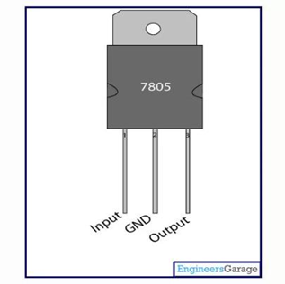

*Figure 14: Pin Diagram of Voltage Regulator*

|  |  |  |
| --- | --- | --- |
| **Pin No** | **Function** | **Name** |
|  |  |  |
| 1 | Input voltage (5V-18V) | Input |
|  |  |  |
| 2 | Ground (0V) | Ground |
|  |  |  |
| 3 | Regulated output; 5V (4.8V-5.2V) | Output |
|  |  |  |

*Table 1: Pin Description of Voltage Regulator IC 7805*

17

**2.2.5 Buzzer:**

An audio signaling device like a beeper or buzzer may be electromechanical or piezoelectric or mechanical type. The main function of this is to convert the signal from audio to sound. Generally, it is powered through DC voltage and used in timers, alarm devices, printers, alarms, computers, etc. Based on the various designs, it can generate different sounds like alarm, music, bell & siren.

The pin configuration of the buzzer is shown below. It includes two pins namely positive and negative. The positive terminal of this is represented with the ‘+’ symbol or a longer terminal. This terminal is powered through 6Volts whereas the negative terminal is represented with the ‘-‘symbol or short terminal and it is connected to the GND terminal.

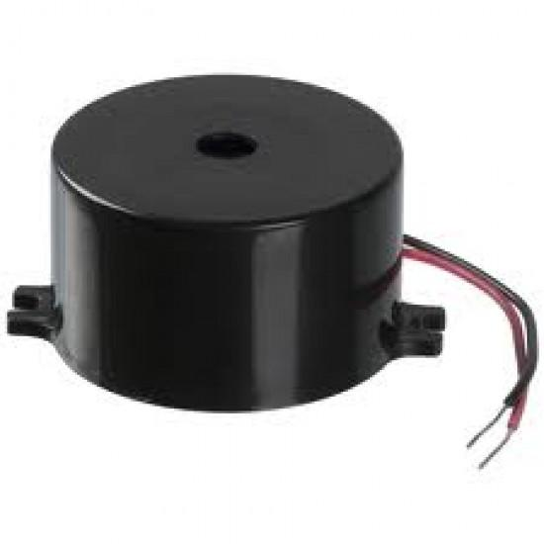

*Figure 15: Buzzer*

**Working Principle:**

The working principle of a buzzer depends on the theory that, once the voltage is given across a piezoelectric material, then a pressure difference is produced. A piezo type includes piezo crystals among two conductors.

Once a potential disparity is given across these crystals, then they thrust one conductor & drag the additional conductor through their internal property. So this continuous action will produce a sharp sound signal.

18

**2.2.6 BC547 Transistor:**

The BC547 transistor is an NPN Transistor. A transistor is nothing but the transfer of resistance that is used for amplifying the current. A small current of the base terminal of this transistor will control the large current of the emitter and base terminals. The main function of this transistor is to amplify as well as switch purposes. The maximum gain current of this transistor is 800A.

Similar transistors are BC548 & BC549. This transistor works in a fixed DC voltage in the preferred region of its characteristics which is called biasing. Further, the series of this transistor can be divided into three groups based on the current gain BC547A, BC547B & BC547C.

**Working States of Transistor:**

BC547 Works in two states 1. Forward Bias and 2. Reverse Bias.

In a forward bias mode, the two terminals like emitter & collector are connected to allow the flow of current through it. Whereas in a reverse bias mode, it doesn’t allow the flow of current through it because it works as an open switch.

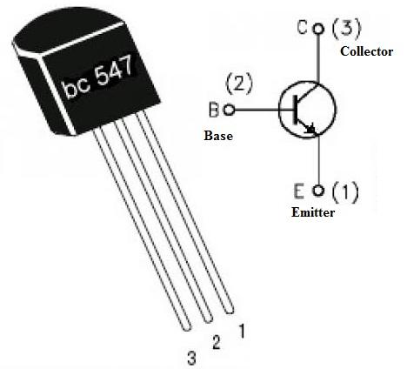

*Figure 16: Pin Diagram of Transistor*

**Features**

* The gain of DC current (hFE) = 800 A
* Continuous Ic (collector current) = 100mA
* VBE (emitter-base voltage) = 6V
* IB (base current) = 5mA
* The transition frequency is 300MHz
* Power dissipation is 625mW

19

**2.3 Software Requirement:**

**2.3.1 Arduino IDE:**

The ARDUINO Software (IDE) is an open-source makes it easy to write code and upload it to the ARDUINO board. The Arduino integrated development environment (IDE) is a cross-platform application (for Windows, macOS, and Linux) that is written in the programming language Java. It is used to write and upload programs to Arduino compatible boards, but also, with the help of 3rd party cores, other vendor development boards.

The source code for the IDE is released under the GNU General Public License, version 2. The Arduino IDE supports the languages C and C++ using special rules of code structuring. The Arduino IDE supplies a software library from the Wiring project, which provides many common input and output procedures. User-written code only requires two basic functions, for starting the sketch and the main program loop, which is compiled and linked with a program stub main () into an executable cyclic executive program with the GNU toolchain, also included with the IDE distribution. The Arduino IDE employs the program avr to convert the executable code into a text file in hexadecimal encoding that is loaded into the Arduino board by a loader program in the board's firmware.

Programs written using ARDUINO Software (IDE) are called sketches. These sketches are written in the text editor and are saved with the file extension (.ino). The editor has features for cutting/pasting and for searching/replacing text. The message area gives feedback while saving and exporting and also displaces errors. The console displaces text output by ARDUINO software (IDE), including complete error messages and other information.

When a sketch is uploaded, the ARDUINO boot loader, a small program that has been loaded onto the microcontroller on your board is used. It allows uploading the code without using any additional hardware. The boot loader is active for a few seconds when the board resets; it starts whichever sketch was most recently uploaded to the microcontroller. The boot loader will blink the onboard (pin 13) LED when it starts.

**2.3.2 Fritzing Software Tool**

Fritzing is a software tool that allows users to document these electronic prototype projects and share them with others. Due to its intuitive approach, it can help teach electronics to people without an engineering background.

20

Fritzing provides a powerful means to projects. The user simply recreates the circuit in software and saves it to a project file. The abstract yet reality-based representation is intuitive to read, can be discussed with colleagues and teachers, or published on a website for re-use and inspection by other users.

In this project, Fritzing S/w tool is used for the virtual circuit implementation. It is very useful in cost-cutting as it is very difficult and costly to implement a circuit physically on a prototype/initial phase.

**2.3.3 Blynk App (Open S/w):**

Blynk was designed for the Internet of Things. It can control hardware remotely, it can display sensor data, can store data, visualize it, and do many other cool things.

There are three major components in the platform:

**Blynk App**- allows to you create amazing interfaces for your projects using various widgets we provide.

**Blynk Server**- responsible for all the communications between the smartphone and hardware. You can use our Blynk Cloud or run your private Blynk server locally. It’s open-source, could easily handle thousands of devices, and can even be launched on a Raspberry Pi.

**Blynk Libraries**- for all the popular hardware platforms - enable communication with the server and process all the incoming and outcoming commands.

21

**CHAPTER 3**

**CIRCUIT DIAGRAM & IMPLEMENTATION OF PROPOSED SYSTEM**

**3.1 Circuit diagram:**

The circuit diagram of the proposed system is explained under the following two sections:

**3.1.1 First Prototype Automation System Based on a single Node-MCU:**

In the circuit diagram of this project Node-MCU work as a motherboard of our automation system which is biased on Microcontroller ESP8266. Node MCU operates at 3.3V-5V.

Here we are connected two relay R1, R2 at pin number 11,12 of Node-MCU respected, for output of Relay we are using two LED which operates at 3.3V, two IR sensors are used at pin number 3,4 of Node-MCU respectively and the output display at LED (16x2).

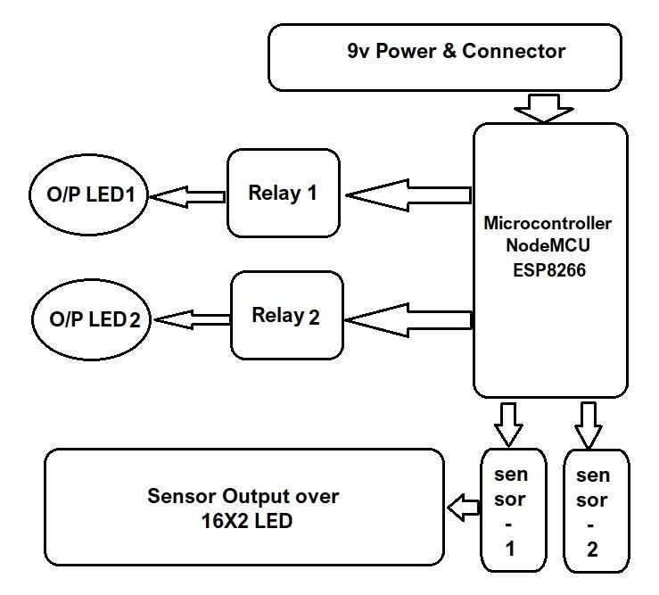

*Figure 17: Diagram of single (Node-MCU ESP8266) based automation system*

22

In figure 18 Circuit diagram of the external Relay circuit for our automation system represents that in this circuit board there are two relays R3, R4 which are connected with the connector and power source of the previous one circuit, the output of these two relay show at LED1 and LED2. At this phase, we controlled our circuit board at 9V of battery supply.

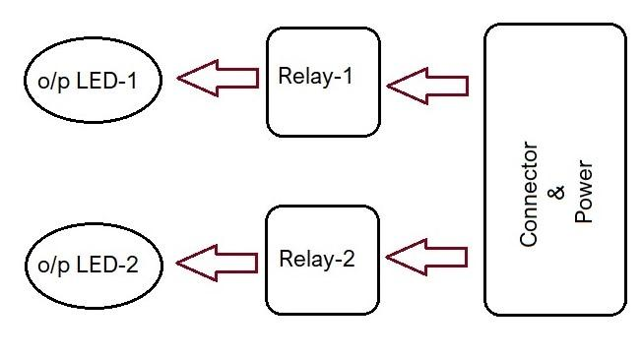

*Figure 18: Circuit diagram of external Relay circuit for our automation system.*

Figure 19 shows the Prototype design using Fritzing Tool after the implementation of the circuit block diagram we implement our circuit on the Fzitzing tool. Fritzing is a software tool that allows users to document these electronic prototype projects and share them with others. Due to its intuitive approach, it can help teach electronics to people without an engineering background. We implement our wired circuit using this tool kit and after this, the system works properly.

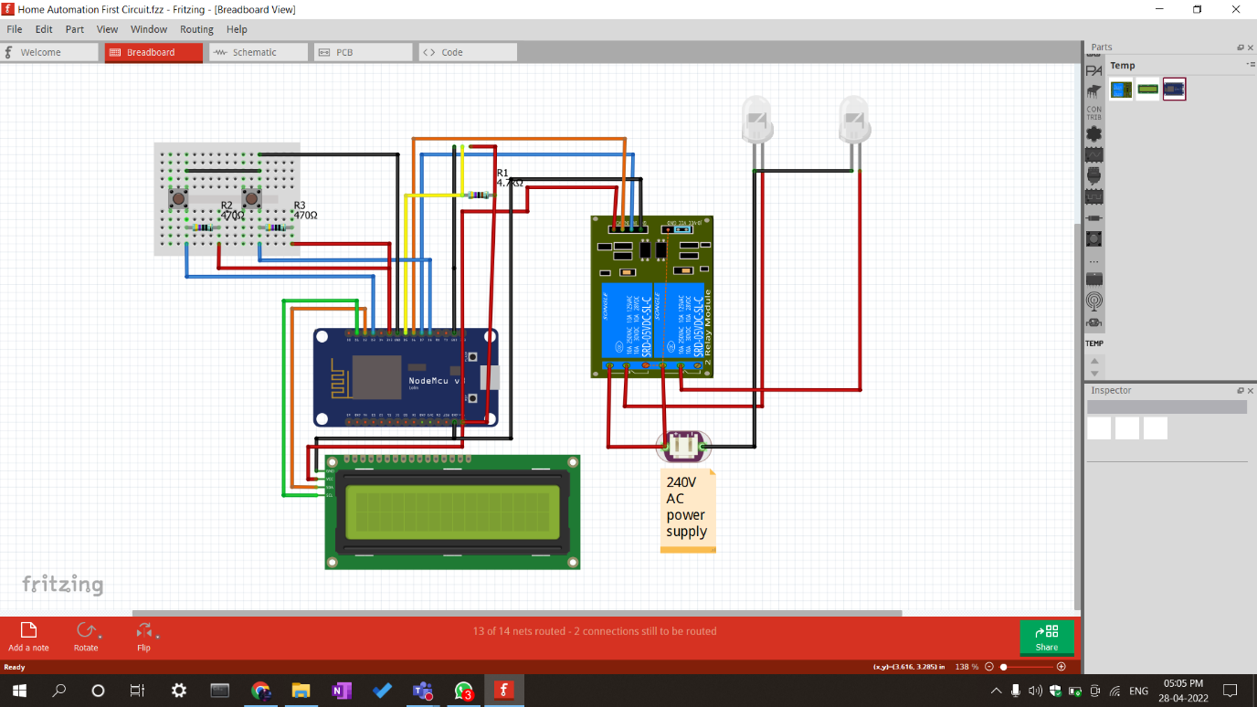

*Figure 19: Prototype design of using Fritzing Tool*

23

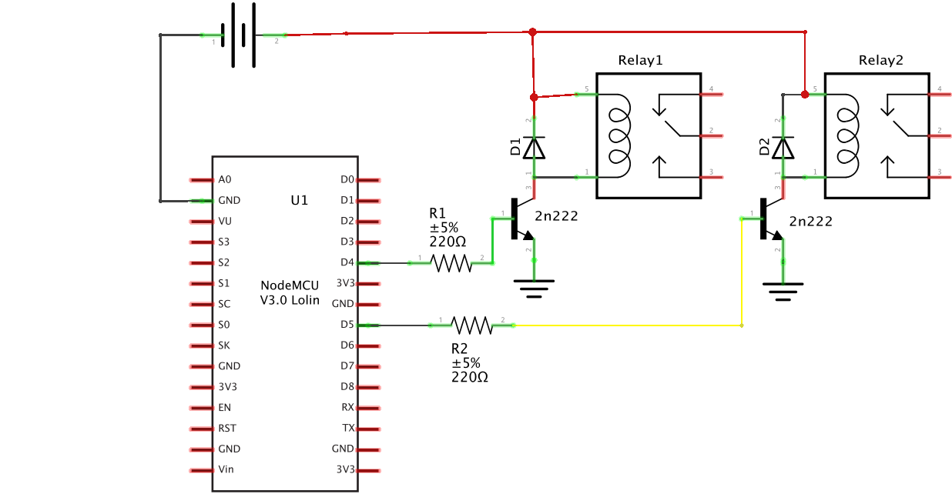

*Figure 20: Schematic Diagram of single Node-MCU (ESP8266) based system*.

Figure 21 shows that the First Hardware prototype with properly connected via wired.

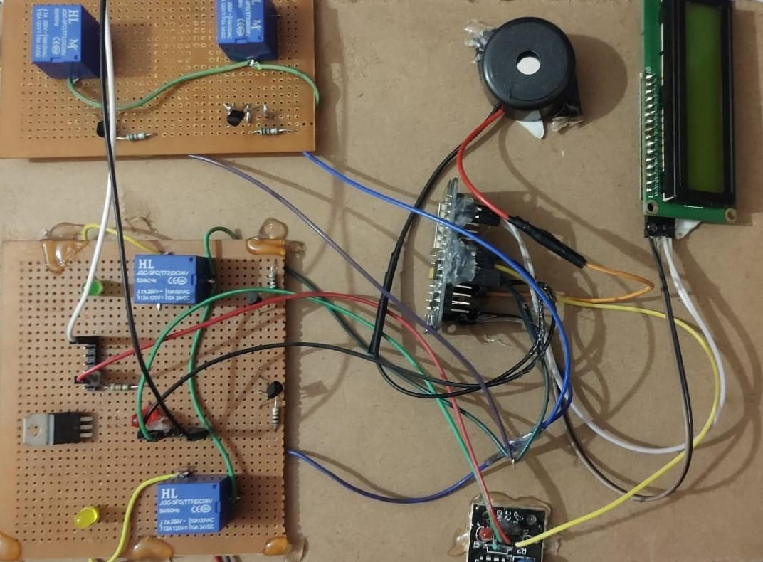

Figure 21: First Hardware prototype.

24

**3.1.2 Final Prototype Automation System Based on dual Node-MCU:**

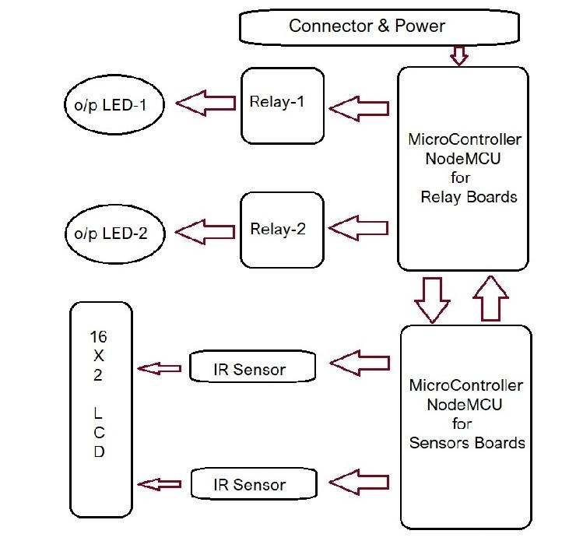

*Figure 22: Circuit diagram of dual microcontroller (Node-MCU ESP8266) based automation system.*



*Figure 23: Circuit diagram of external Relay circuit for our automation system*.

25

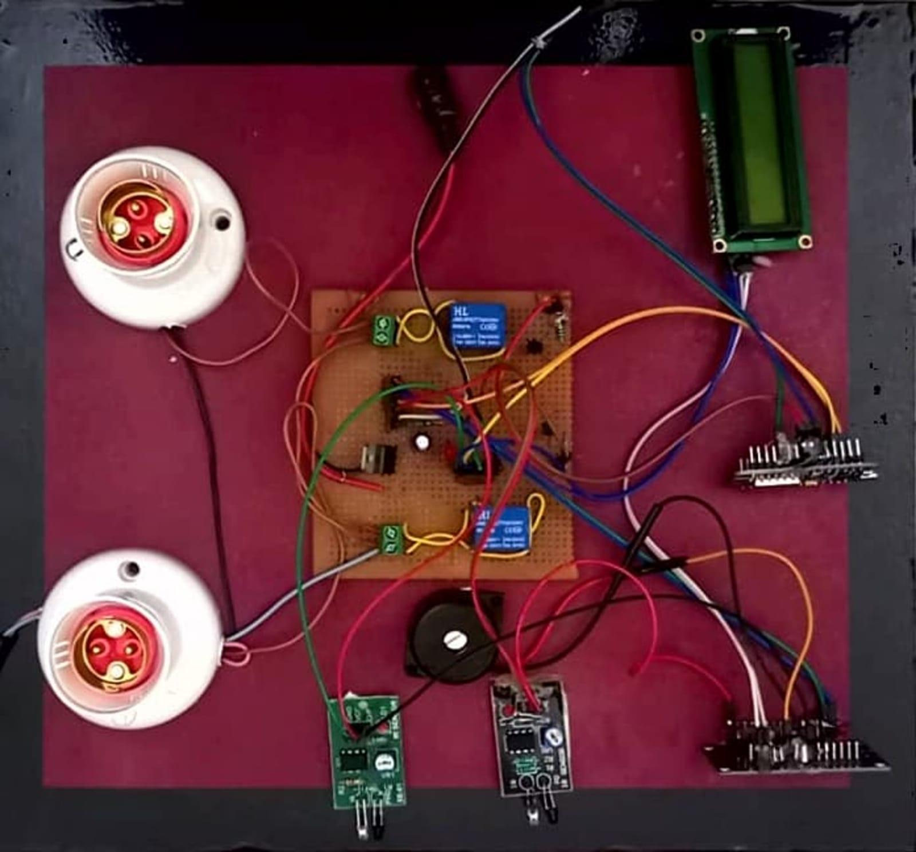

*Figure 24: Final project overview*.

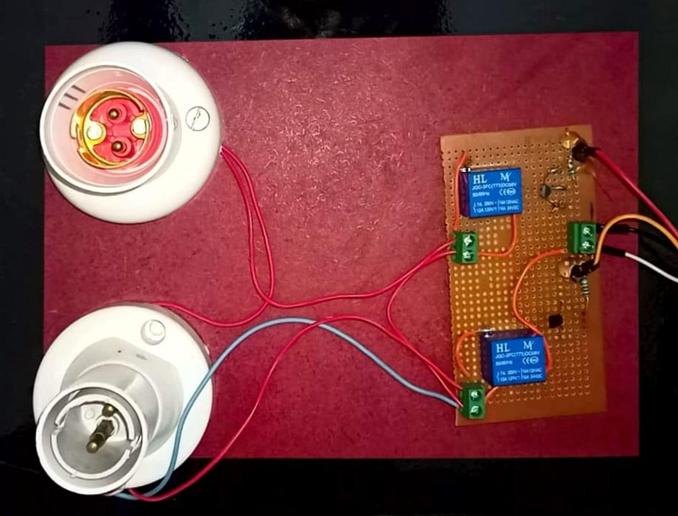

*Figure 25: Final external Relay circuit*.

26

**CHAPTER 4**

**RESULT AND CONCLUSION**

**4.1 Result**

After the implementation of the proposed system user can upgrade and expand the automation system. In past, when a user needs to implement a new sensor or when he wants to operate a new AC component. They need to install a whole new setup and it became too costlier and it is a complex process. In our proposed solution-based automation system whenever users want to upgrade, extend or install a new sensor they don’t need to change the existing system they can implement it any time in the future. It saves the cost of the automation system and reduces the complexity of new setups.

**4.2 Advantages**

* This project is helpful for both domestic and industrial automation expeditions.
* This project is user end upgradable and open-source reprogrammable.
* This project is connected with the Blynk IoT server which makes it controllable world widely.
* It has a separated sensor microcontroller that saves the cost of the sensor and reduces the complexity of implementation.

**4.3 Limitation**

* User should know the programming
* Whenever any other component is added to the project, complete programming is again burned into the memory.
* Whenever the user updates the hardware, latency is in between 3 to 5 seconds according to the component over the server.

27

**4.3 Conclusion:**

The automation management system faces a great challenge in the form of continuous growth of technology and lack of knowledge of users about the Internet of things. The conventional method is no longer effective enough for solving complex and challenging up-gradation of the automation systems. Due to the increased amount of automation systems and users, it is very important to take effective steps to reduce the complexity and make it user-end upgradable and open-source reprogrammable. This project replaces the conventional automation system from domestic and industry setup.

This project can operate and control all AC equipment that is present at home and industry (up to 220 volts) using only a relay module because sometimes, a user doesn’t want to use any sensor in his custom automation, here our system is able to work without using any sensor, in case user want to use sensors in future, that is possible due to separated sensor microcontroller.

28

**Reference:**

[1] Piyare, Rajeev, and M. Tazil. "Bluetooth-based home automation system using cell phone." *2011 IEEE 15th International Symposium on Consumer Electronics (ISCE)*. IEEE, 2011.

[2] Gill, Khusvinder, "A Zigbee-based home automation system." *IEEE Transactions on consumer Electronics* 55.2 (2009).

[3] Jivani, M. Nath "GSM based home automation system using app-inventor for android mobile phone." *International Journal of Advanced Research in Electrical, Electronics and Instrumentation Engineering* 3.9 (2014).

[4] Morshed, Neaz Md, "Microcontroller based home automation system using Bluetooth, GSM, Wi-Fi and DTMF." *2015 International Conference on Advances in Electrical Engineering (ICAEE)*. IEEE, (2015).

[5 ]Malik, Neha, and Y. Bodwade. "Literature review on home automation system." *Int. J. Adv. Res. Comput. Commun. Eng.(IJARCCE)* 6.3 (2017).

[6] Javale, Deepali, "Home automation and security system using Android ADK." *International journal of electronics communication and computer technology (IJECCT)* 3.2 (2013).

[7] Katuk, Norliza, "Implementation and recent progress in cloud-based smart home automation systems." *2018 IEEE Symposium on Computer Applications & Industrial Electronics (ISCAIE)*. IEEE, 2018.

[8] Rao, P. Bhaskar, and S. K. Uma. "Raspberry Pi home automation with wireless sensors using smart phone." *International Journal of Computer Science and Mobile Computing* 4.5 (2015).

[9] Chowdhury, Md Nasimuzzaman, Md Shiblee Nooman, and Srijon Sarker. "Access Control of Door and Home Security by Raspberry Pi Through Internet." *Int. J. Sci. Eng. Res* 4.1 (2013).

[10] Ansari, Aamir Nizam, "An Internet of things approach for motion detection using Raspberry Pi." *Proceedings of 2015 International Conference on Intelligent Computing and Internet of Things*. IEEE, 2015.

[11] Mihalache, Alexandra. "Wireless Home Automation System using IoT." *Informatica Economica* 21.2 (2017).

**Relay Board Arduino code:**

// Fill-in information from your Blynk Template here

//#define BLYNK_TEMPLATE_ID ""

//#define BLYNK_DEVICE_NAME ""

//#define BLYNK_TEMPLATE_ID "TMPLDjm5hx1q"

//#define BLYNK_DEVICE_NAME "robot"

#define BLYNK_TEMPLATE_ID "TMPLILT44k1Y"

#define BLYNK_DEVICE_NAME "Node-MCU"

#define BLYNK_FIRMWARE_VERSION "0.1.0"

#define BLYNK_PRINT Serial

//#define BLYNK_DEBUG

#include <Wire.h> // This library is already built in to the Arduino IDE

#include <LiquidCrystal_I2C.h> //This library you can add via Include Library > Manage Library >

LiquidCrystal_I2C lcd(0x27, 16, 2);

#define ir A0

#define buzzer 0

int counter=0;

int person=0;

#define APP_DEBUG

// Uncomment your board, or configure a custom board in Settings.h

//#define USE_SPARKFUN_BLYNK_BOARD

//#define USE_NODE_MCU_BOARD

//#define USE_WITTY_CLOUD_BOARD

#include "BlynkEdgent.h"

#define m11 14

#define m12 12

#define m21 13

#define m22 A0

#define pump 15

int pinValue=0;

int pinValue1=0;

int pinValue2=0;

int pinValue3=0;

int pinValue4=0;

int pinValue5=0;

BLYNK_WRITE(V1)

{

pinValue1 = param.asInt(); // assigning incoming value from pin V1 to a variable

}

BLYNK_WRITE(V2)

{

pinValue2 = param.asInt(); // assigning incoming value from pin V1 to a variable

// process received value

}

BLYNK_WRITE(V3)

{

pinValue3 = param.asInt(); // assigning incoming value from pin V1 to a variable

// process received value

}

BLYNK_WRITE(V4)

{

pinValue4 = param.asInt(); // assigning incoming value from pin V1 to a variable

// process received value

}

BLYNK_WRITE(V5)

{

pinValue5 = param.asInt(); // assigning incoming value from pin V1 to a variable

// process received value

}

void setup()

{

Serial.begin(115200);

lcd.init(); // initializing the LCD

lcd.backlight(); // Enable or Turn On the backlight

lcd.print(" Hello Makers "); // Start Printing

pinMode(ir,INPUT);

pinMode(buzzer,OUTPUT);

digitalWrite(buzzer,LOW);

delay(100);

pinMode(m11, OUTPUT);

pinMode(m12, OUTPUT);

pinMode(m21, OUTPUT);

pinMode(m22, OUTPUT);

pinMode(pump, OUTPUT);

BlynkEdgent.begin();

}

void loop()

{

BlynkEdgent.run();

if(pinValue1==1)

{

digitalWrite(m11,HIGH);

Serial.println("forward");

}

else

{

digitalWrite(m11,LOW);

Serial.println("forward");

}

if(pinValue2==1)

{

digitalWrite(m12,HIGH);

Serial.println("backward");

}

else

{

digitalWrite(m12,LOW);

Serial.println("backward");

}

if(pinValue3==1)

{

digitalWrite(m21,HIGH);

Serial.println("left");

}

else

{

digitalWrite(m21,LOW);

Serial.println("left");

}

if(pinValue4==1)

{

digitalWrite(m22,HIGH);

Serial.println("right");

}

else

{

digitalWrite(m22,LOW);

Serial.println("stop");

}

}

**Sensor Arduino Part:**

#include <Wire.h> // This library is already built in to the Arduino IDE

#include <LiquidCrystal_I2C.h> //This library you can add via Include Library > Manage Library >

LiquidCrystal_I2C lcd(0x27, 16, 2);

#define ir A0

#define ir1 12

#define buzzer 14

int counter=0;

int counter1=0;

int person=0;

void setup()

{

Serial.begin(9600);

lcd.init(); // initializing the LCD

lcd.backlight(); // Enable or Turn On the backlight

lcd.print(" Hello Makers "); // Start Printing

pinMode(ir,INPUT);

pinMode(ir1,INPUT);

pinMode(buzzer,OUTPUT);

digitalWrite(buzzer,LOW);

}

void loop()

{

// Nothing Absolutely Nothing!

counter=analogRead(ir);

counter1=digitalRead(ir1);

Serial.println(counter);

if(counter>512)

{

digitalWrite(buzzer,HIGH);

person=person+1;

delay(1000);

digitalWrite(buzzer,LOW);

lcd.clear();

}

else if(counter1==HIGH)

{

digitalWrite(buzzer,HIGH);

person=person-1;

if(person==1){person=0;}

delay(1000);

digitalWrite(buzzer,LOW);

lcd.clear();

}

lcd.setCursor(0,0);

lcd.print("counter");

lcd.setCursor(0,1);

lcd.print(person);

if(person>9)

{

digitalWrite(buzzer,LOW);

}

else

{

digitalWrite(buzzer,HIGH);

}

}

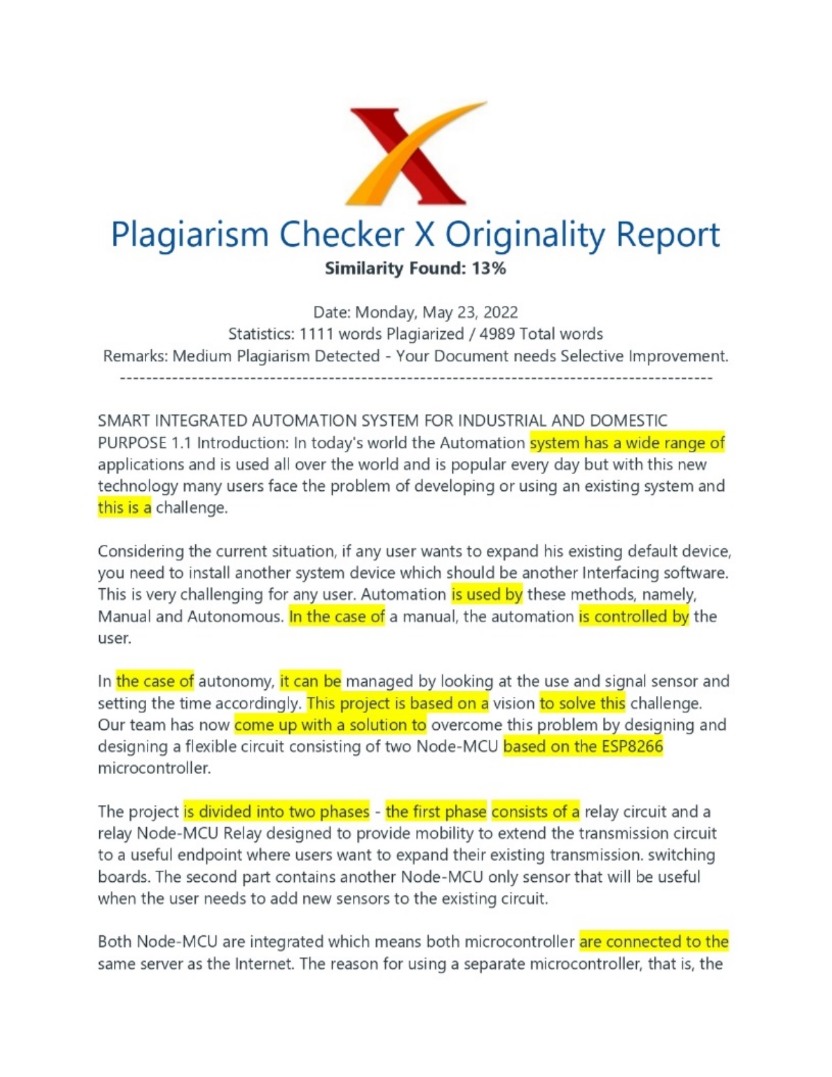Plagiarism Report:

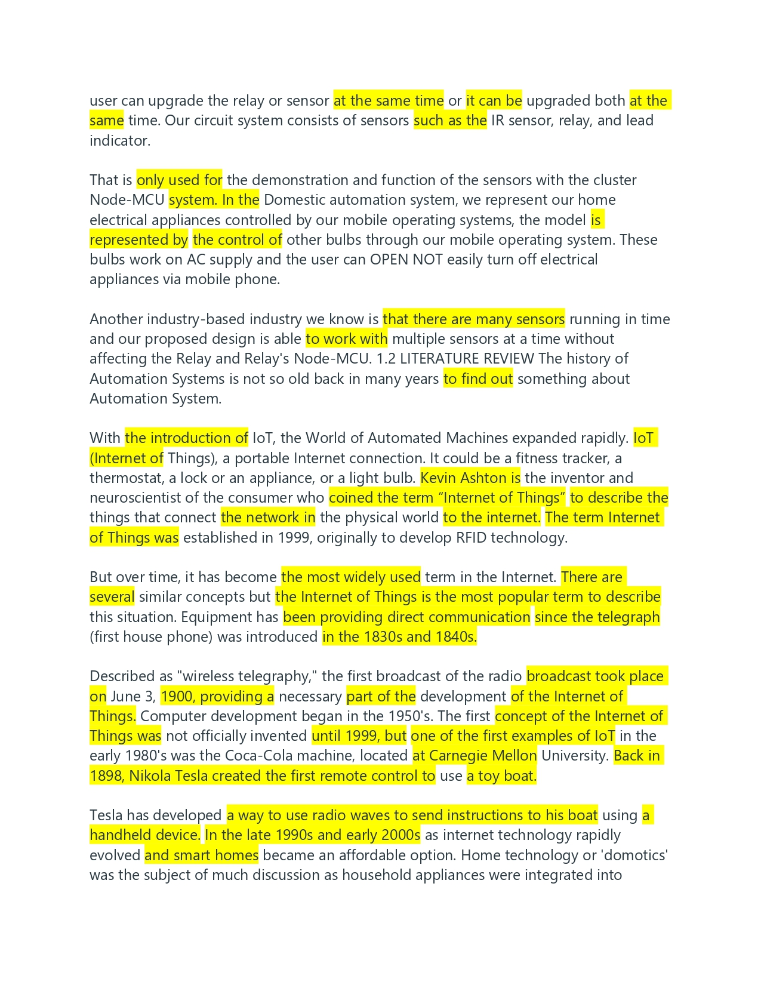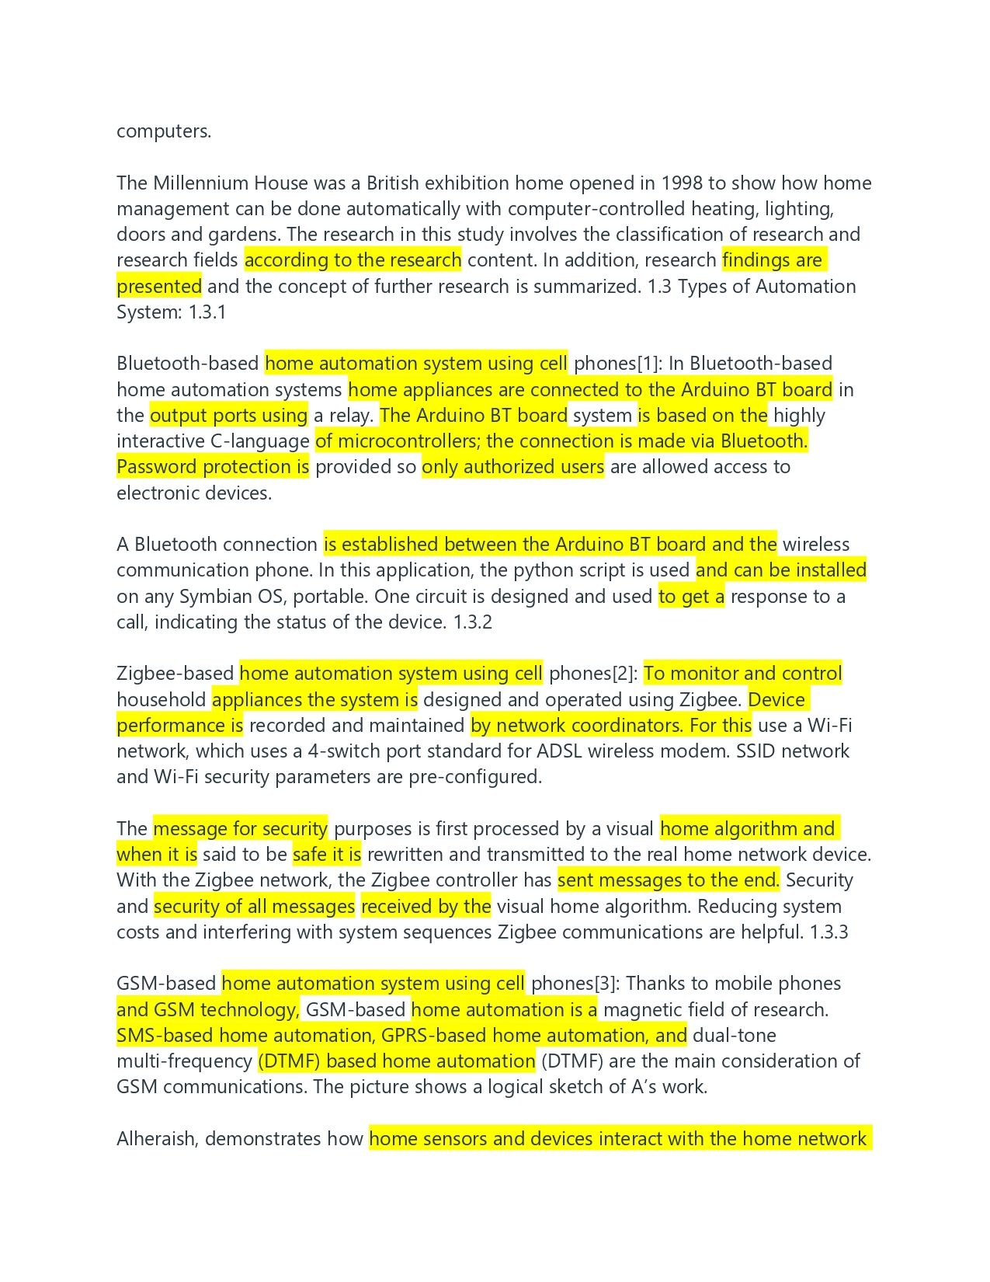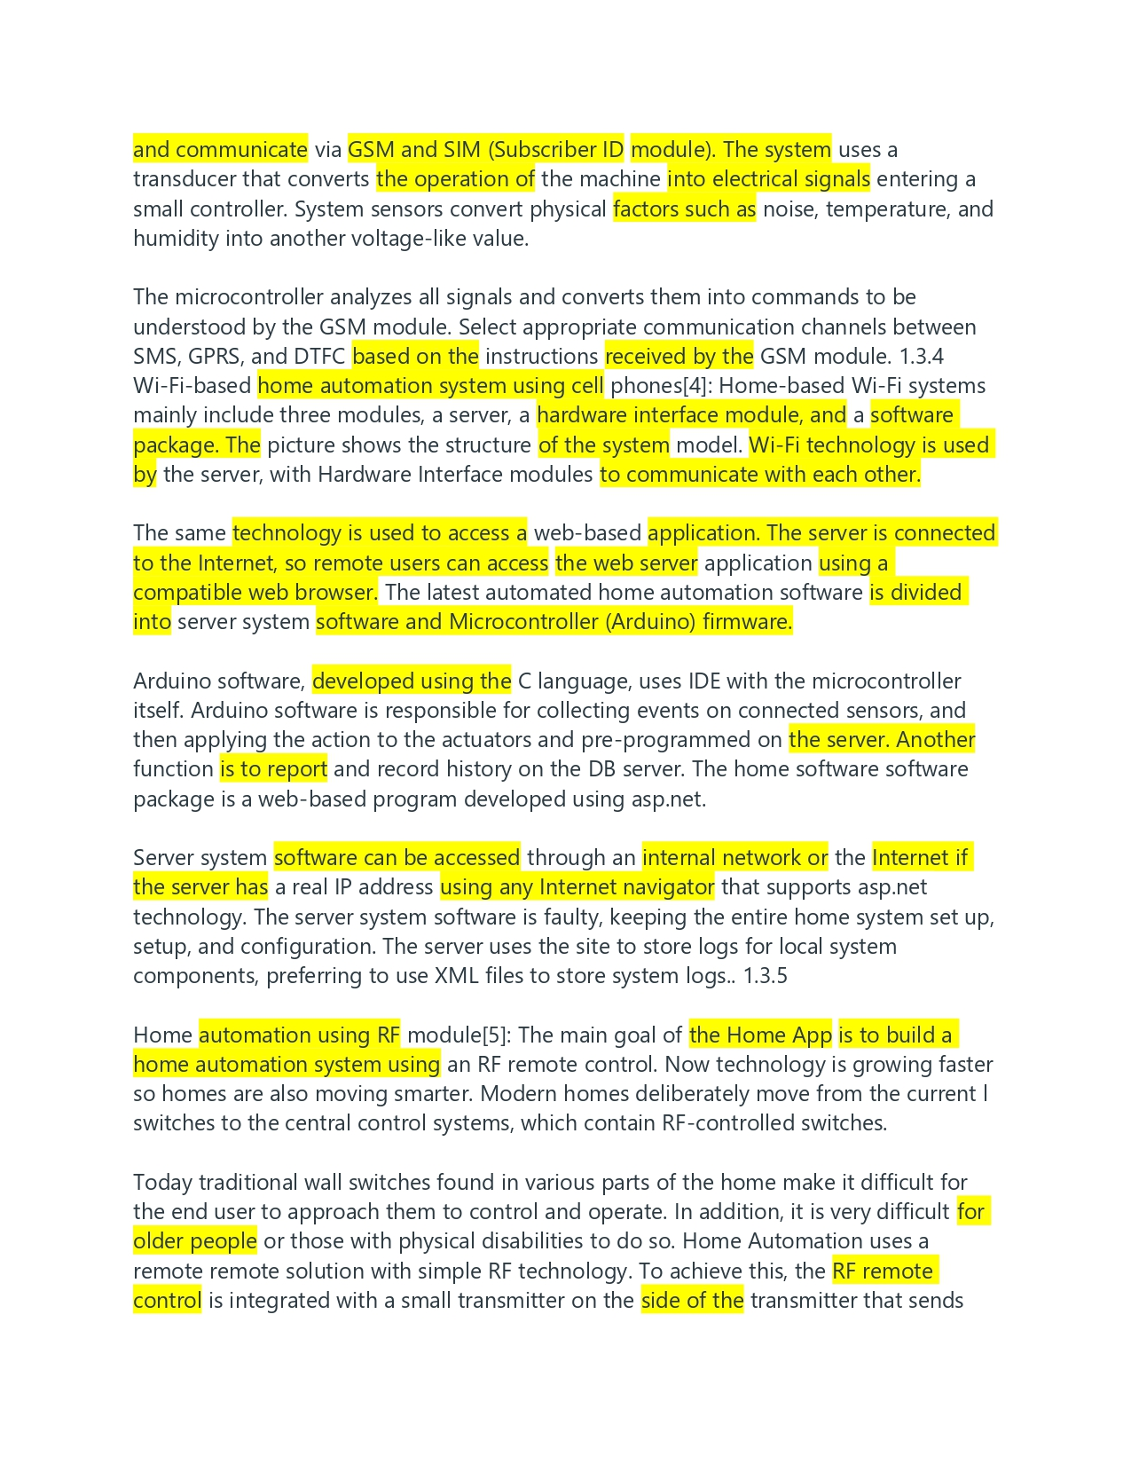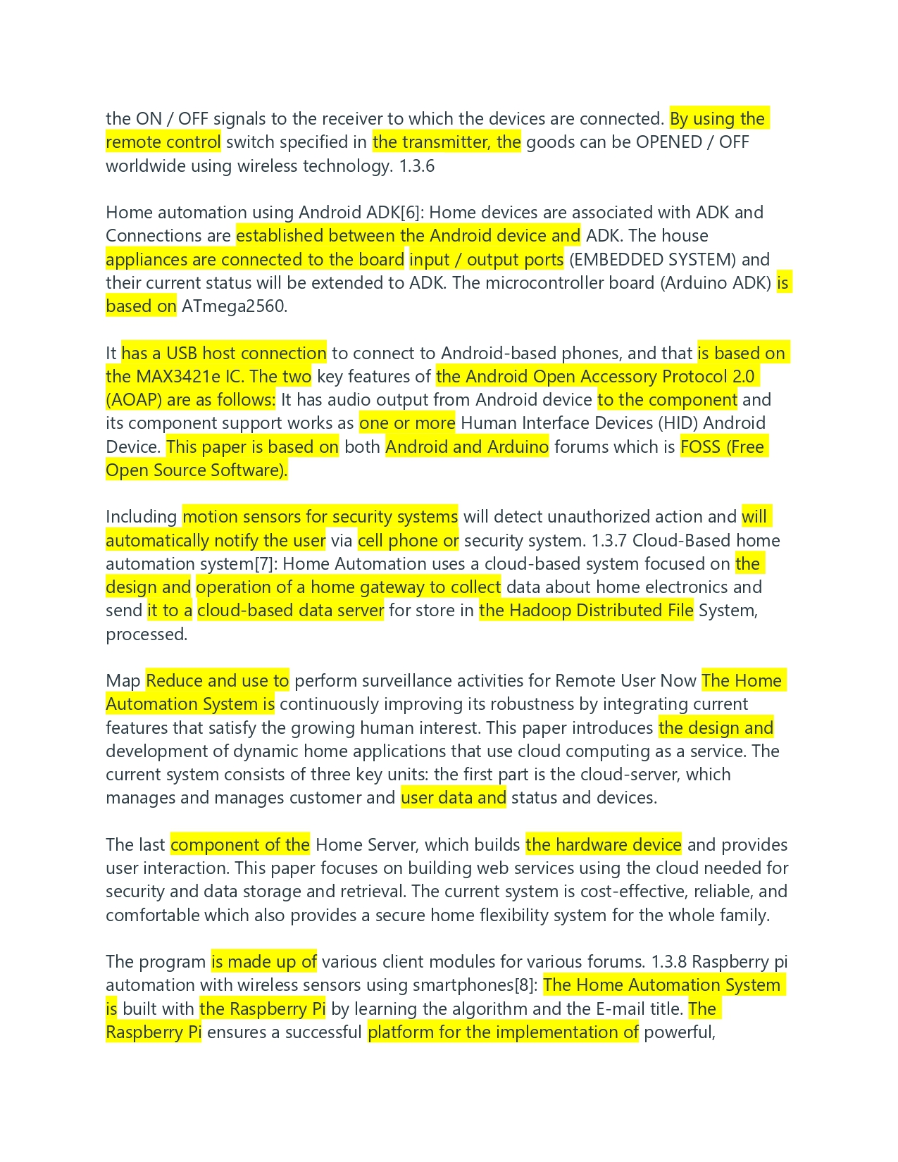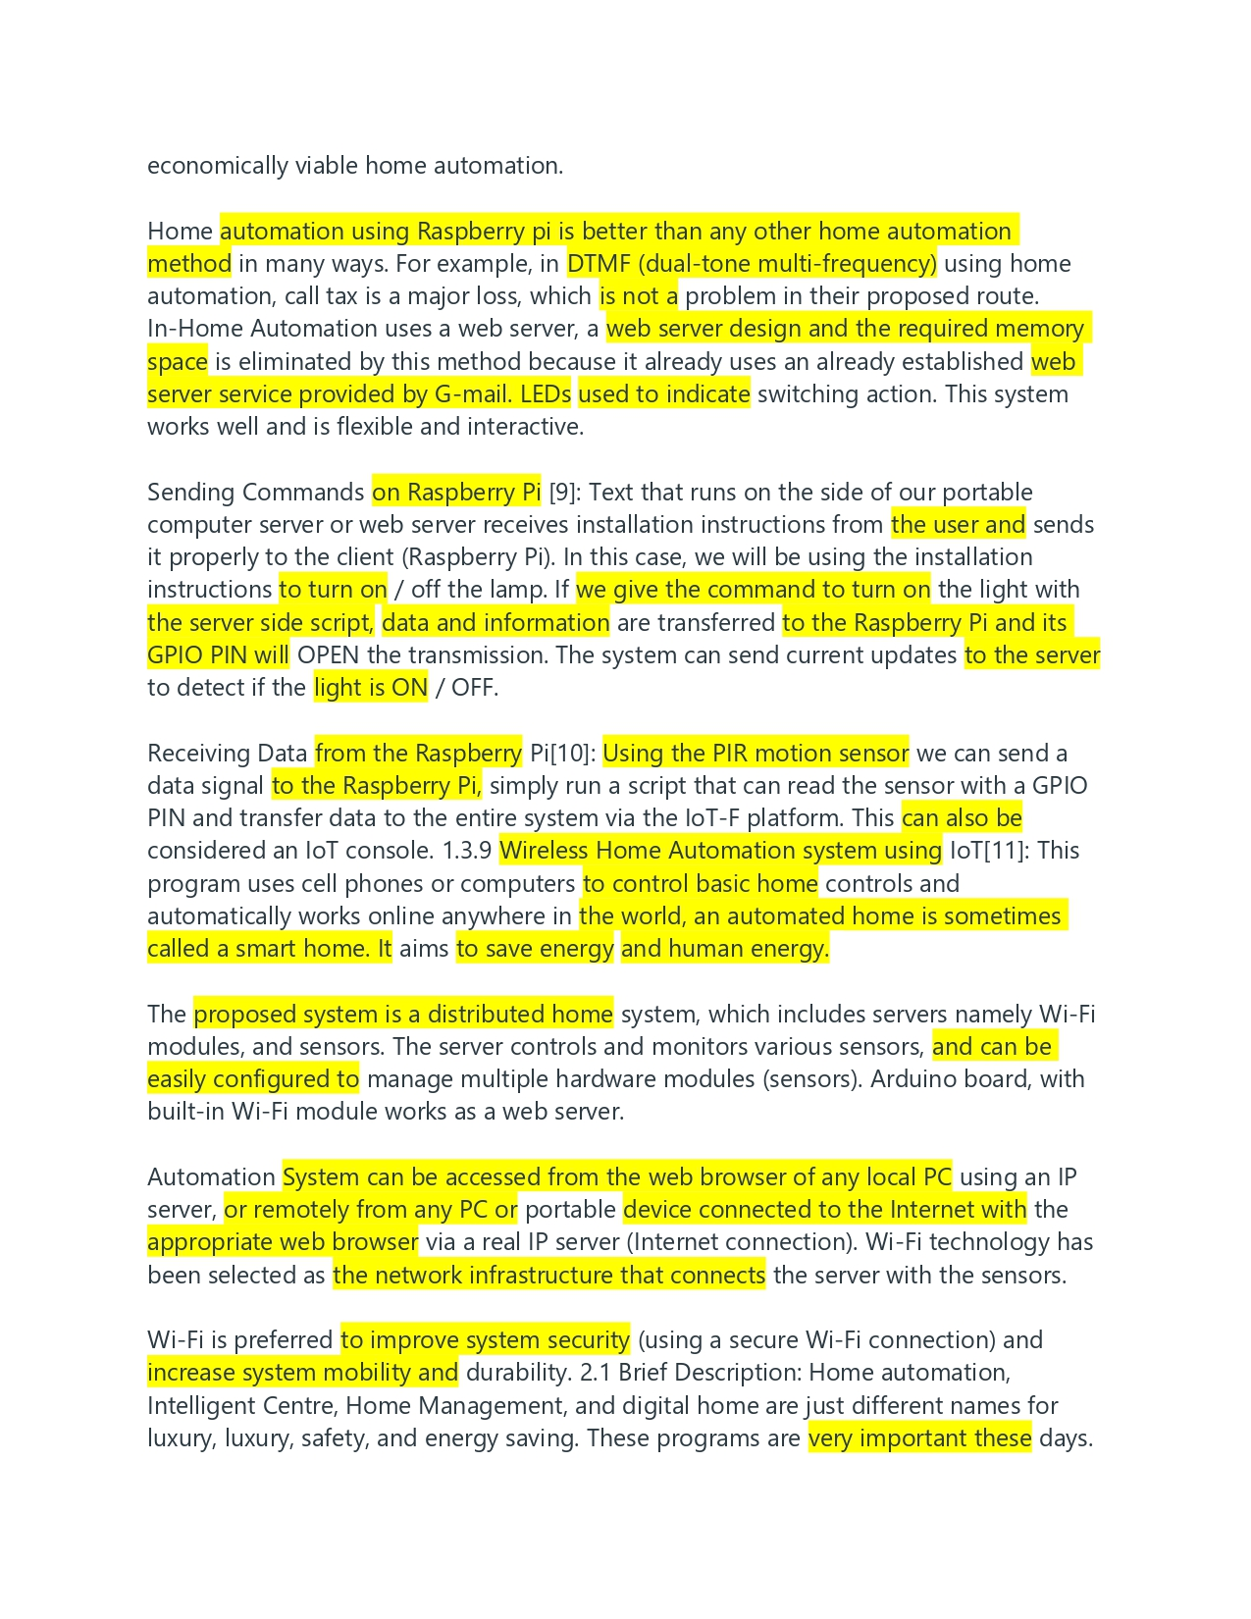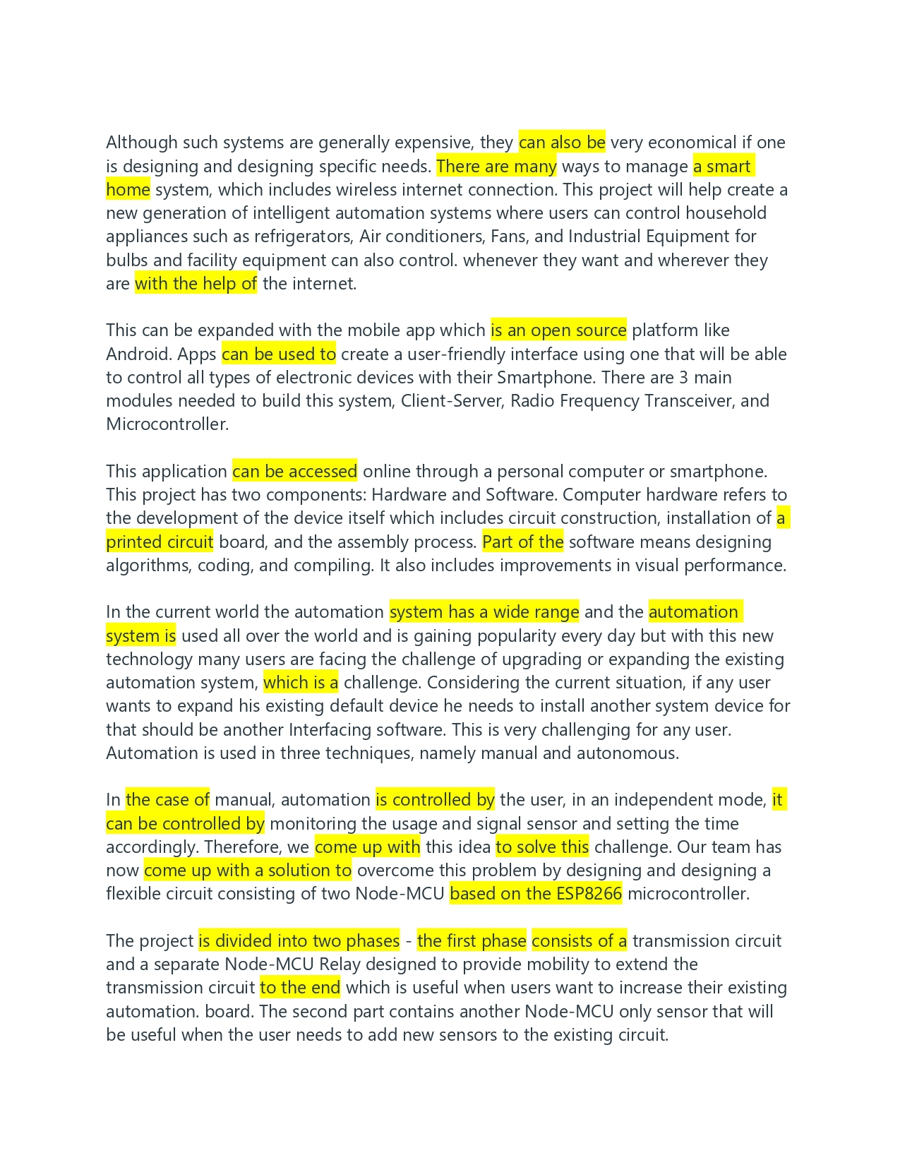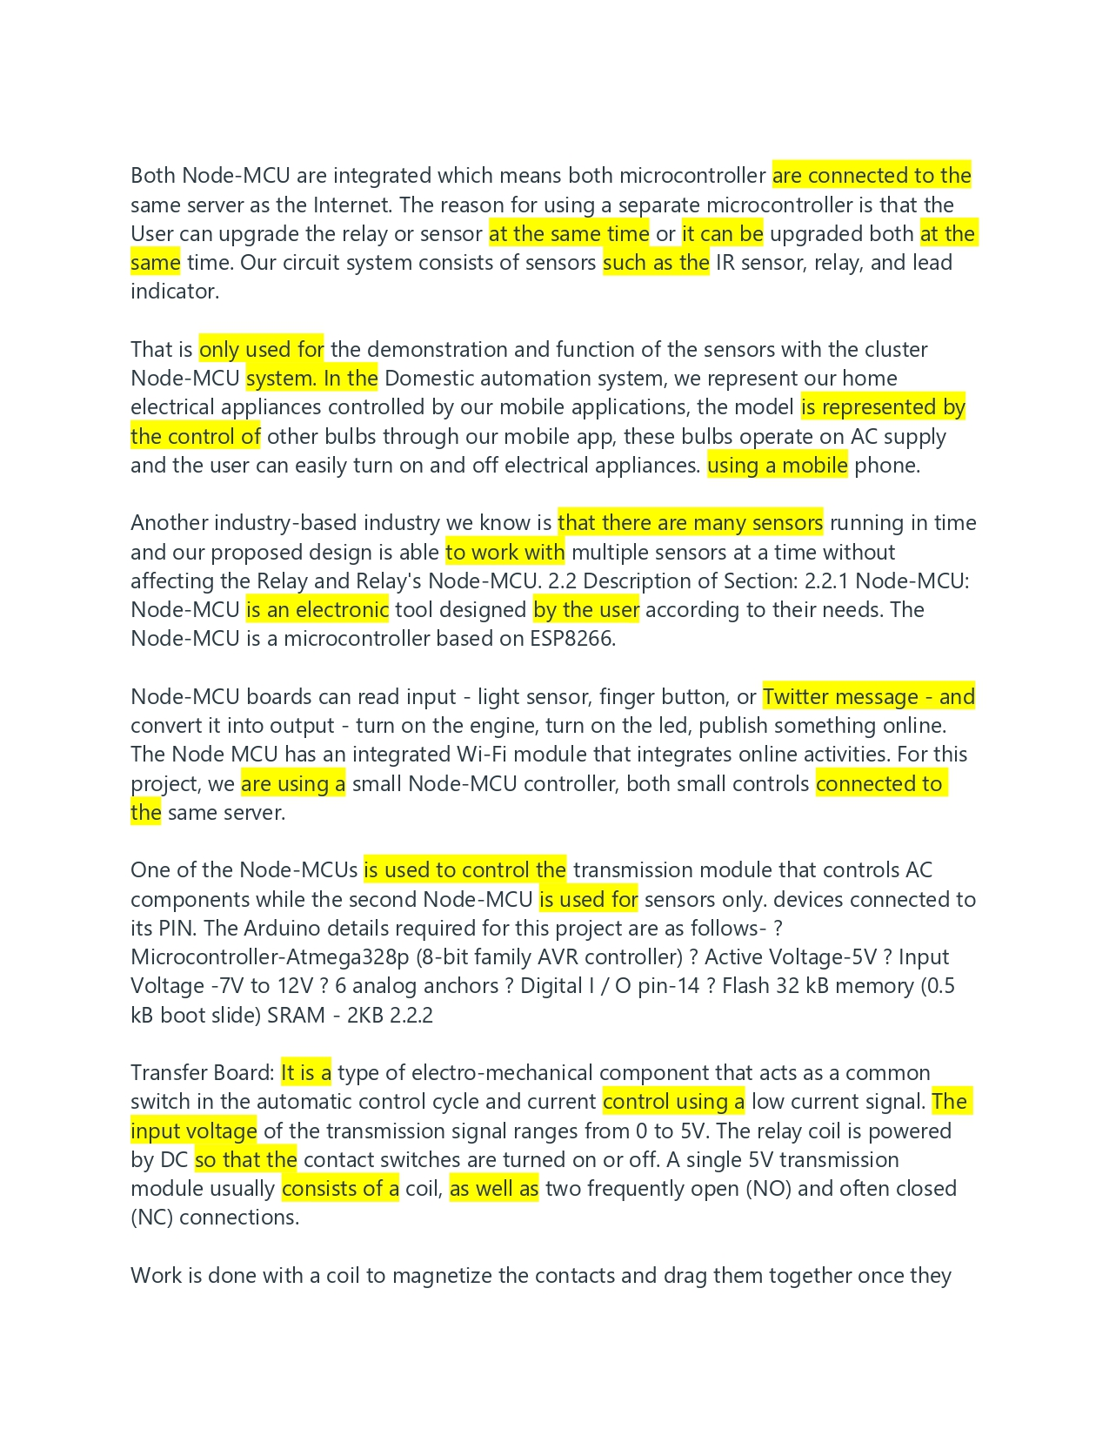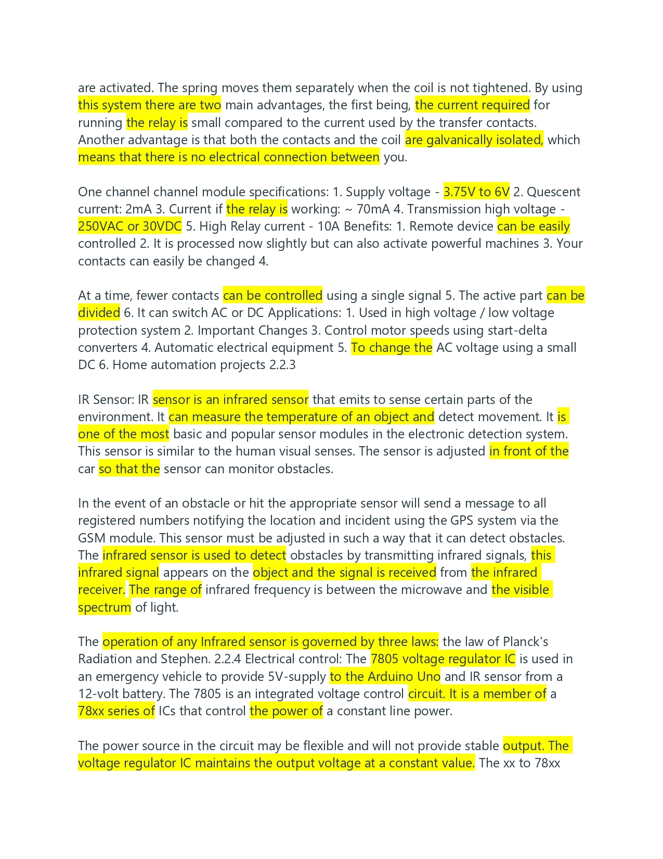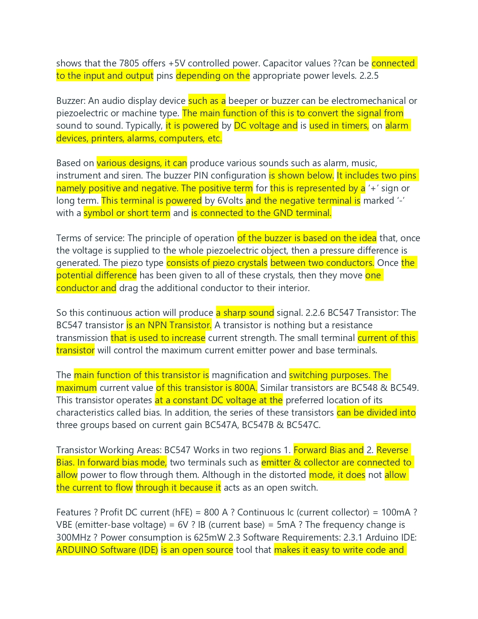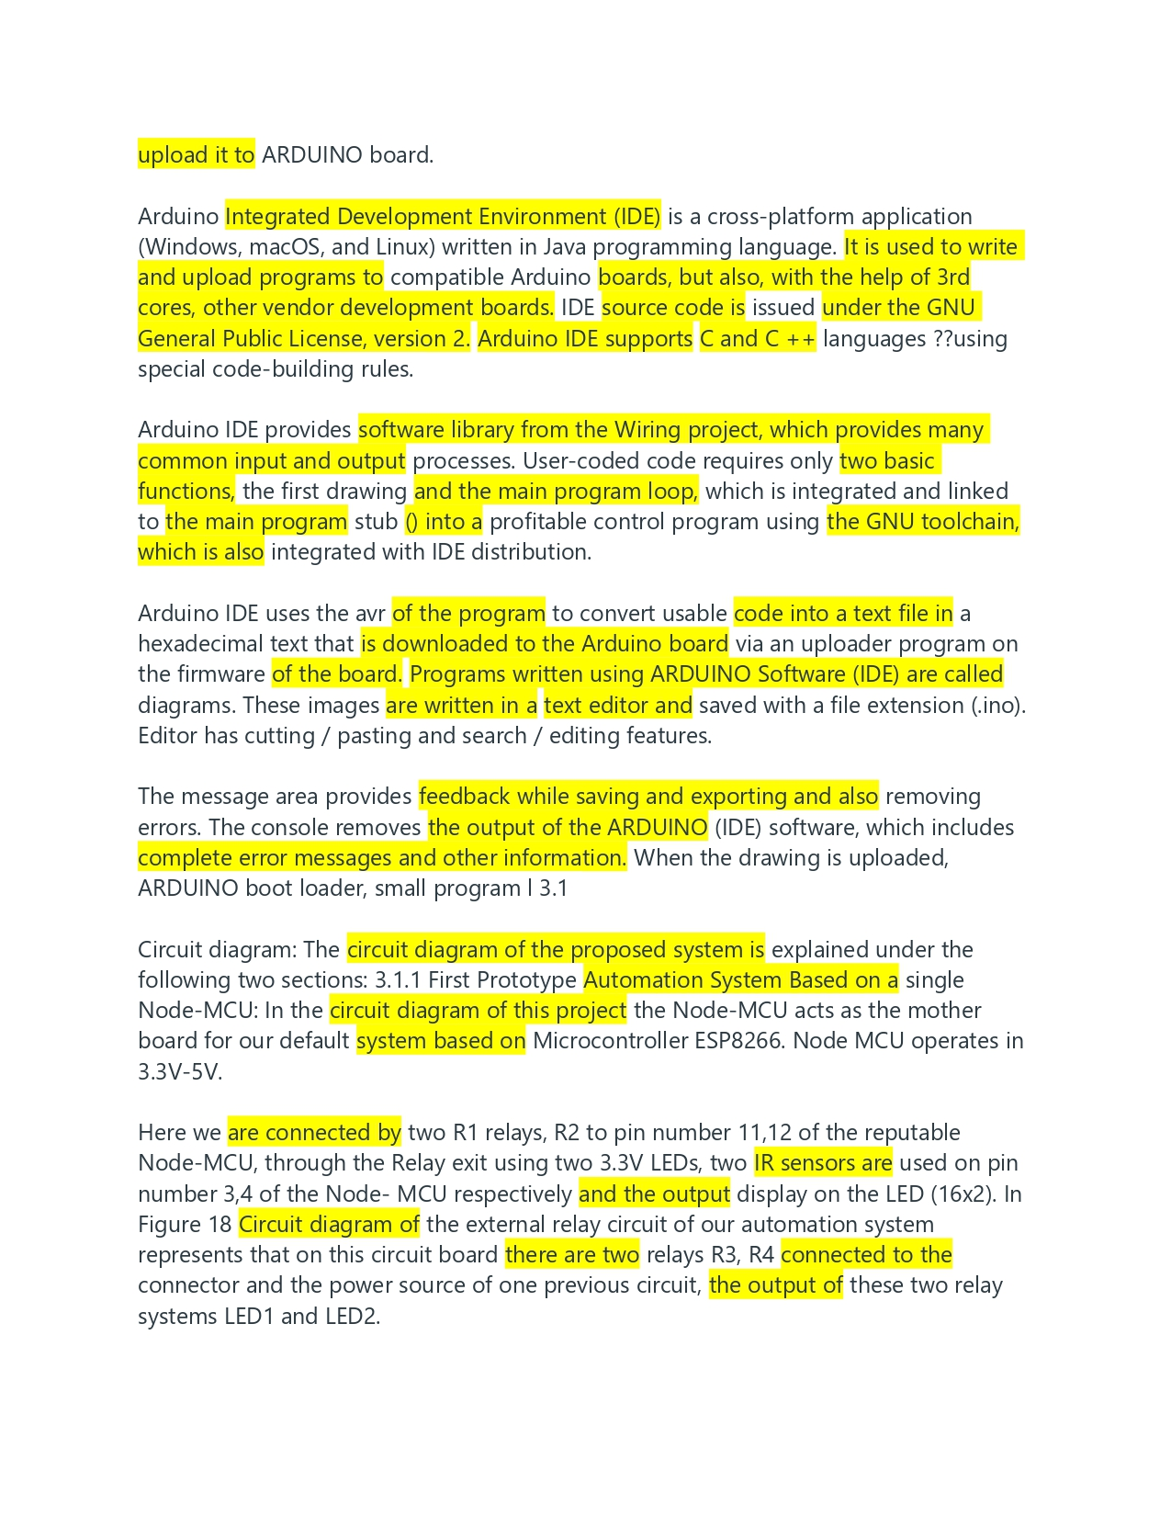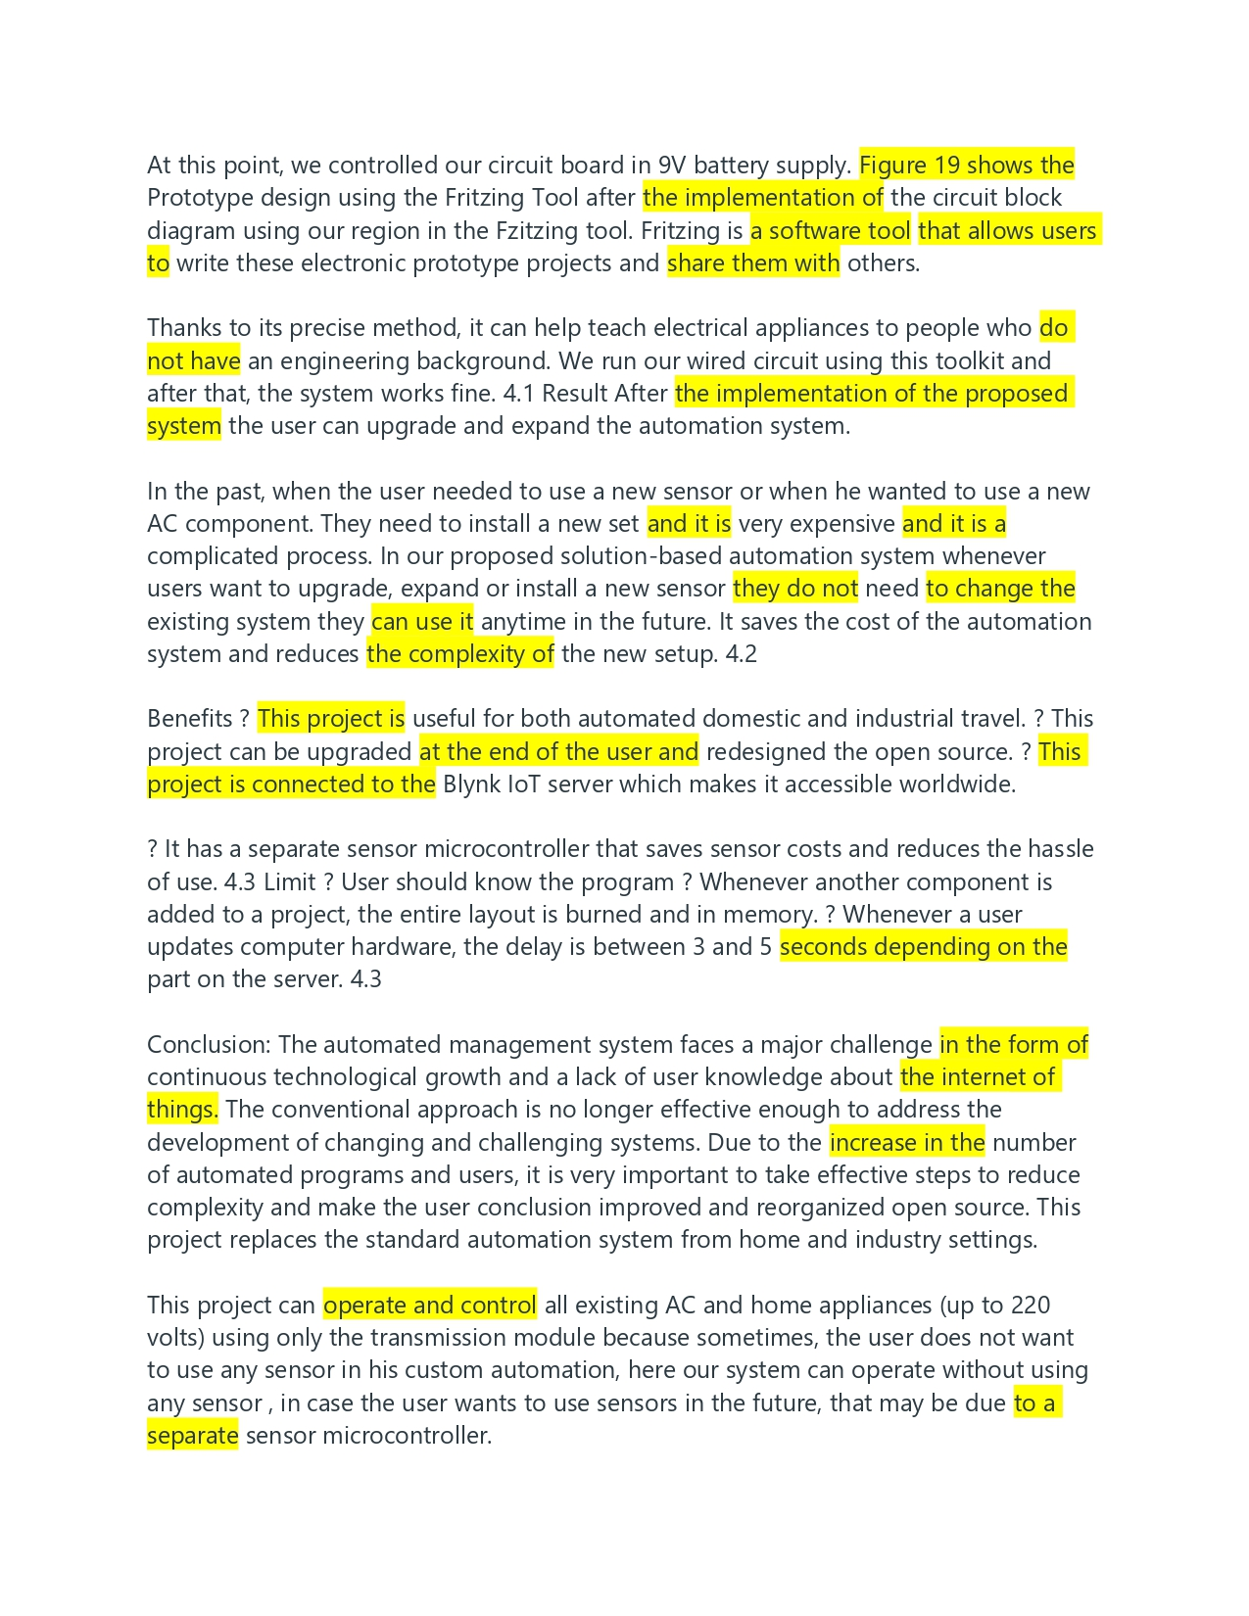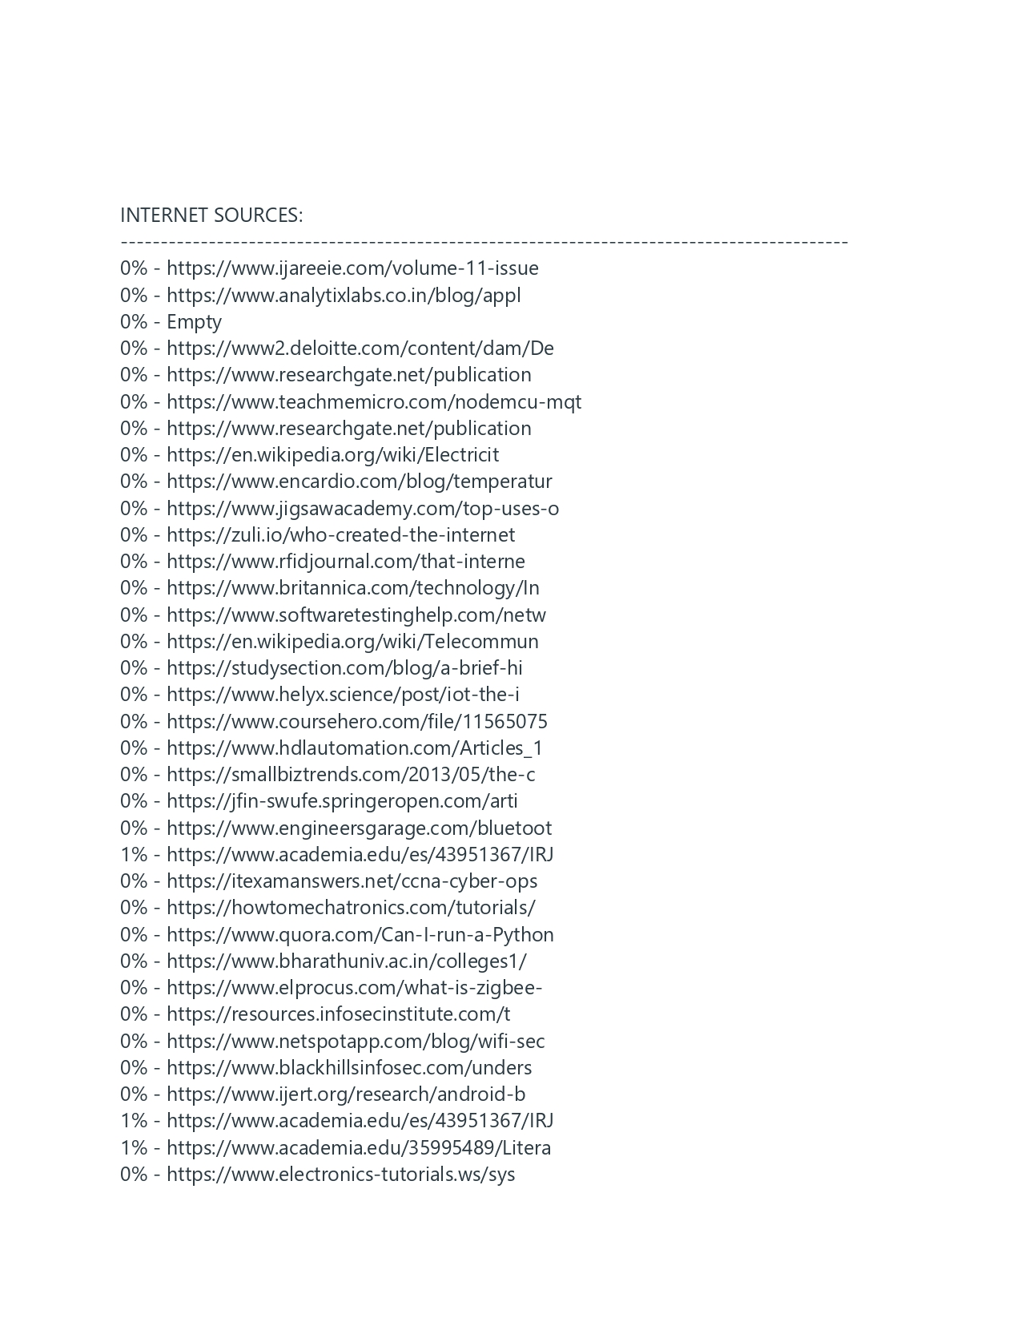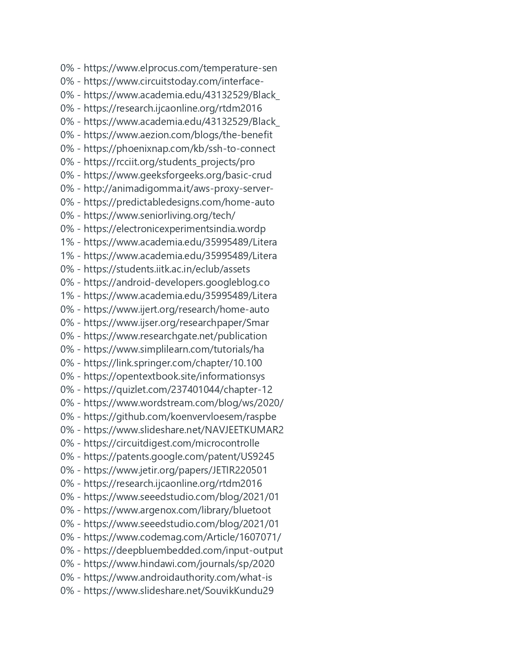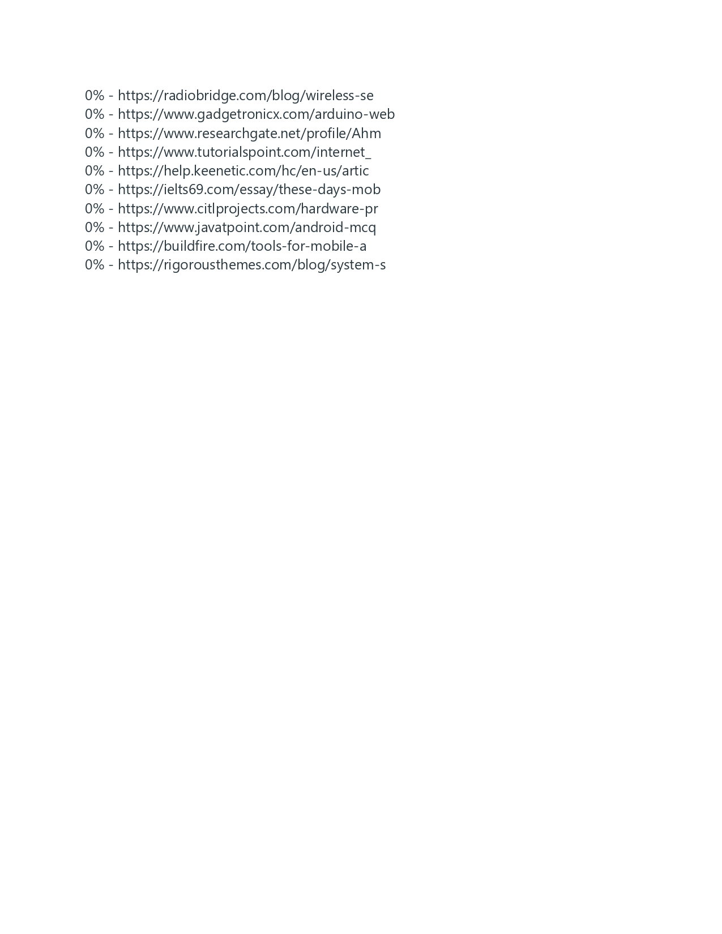

Research Paper Report :